

User Manual for

# NoSkript Client Installation

**Table of Content**

1. Prerequisites 3
2. How to download a NoSkript Client installation setup 3
3. Installation of NoSkript Client Setup 5
4. Verifying NoSkript is accessed from Another Machine 8
5. Selenium Grid 9

Prerequisites:

1. Jdk 11 to be installed in system
2. Add Port 8888 to windows firewall for Client Server Communication
3. Firewall should be enabled for all java rules in both inbound/outbound settings

How to install NoSkript Client Setup

Steps:-

1. Login to NoSkript in browser with given user credentials and after that you are taken to dashboard as shown in below figure.

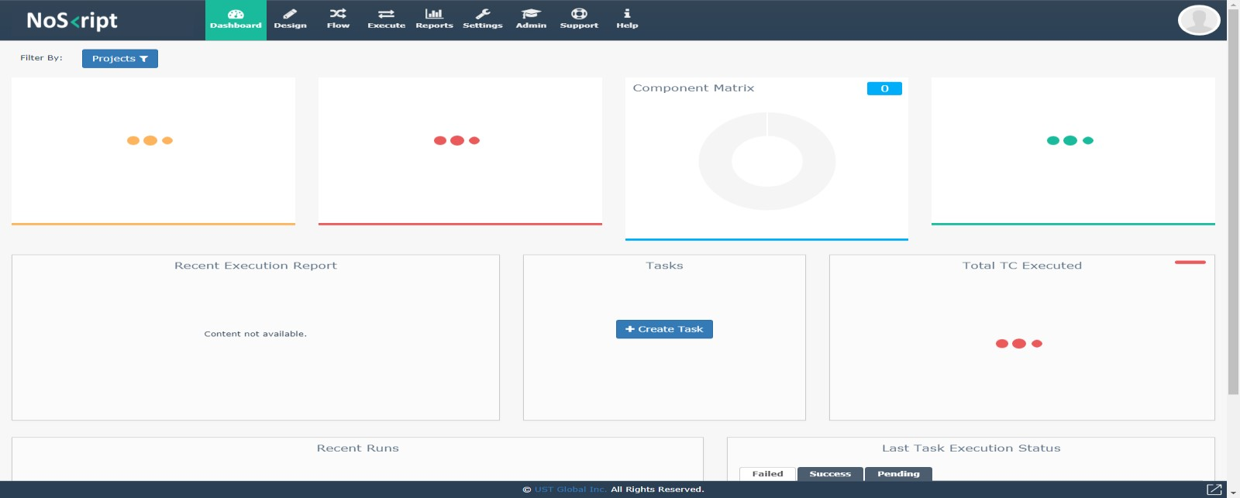

1. On clicking the Help link in the NoSkript, you can see an installer link as shown below

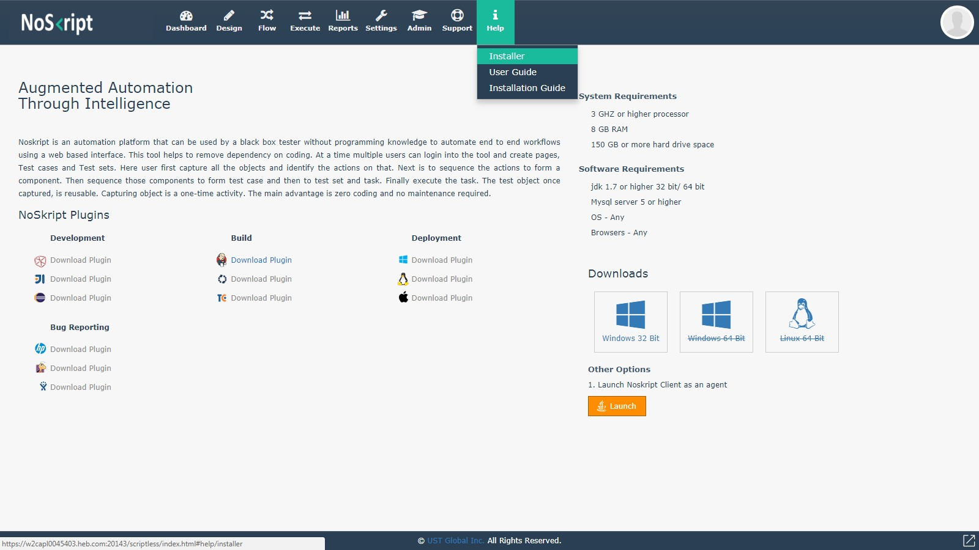

1. On Clicking the Installer link you will be taken to download page as shown below.

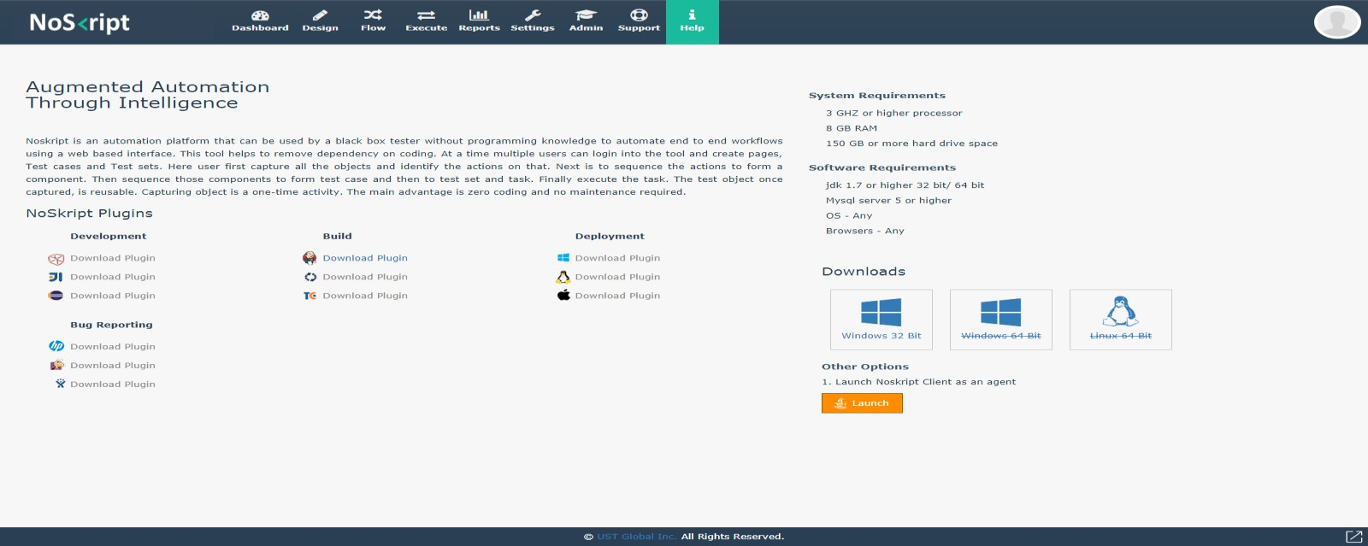

1. Click on “Windows 32 bit” link to download the ScritlessClient.exe

1. Once the ScriptlessClient.exe file is downloaded, copy the ScriptlessClient.exe to D Drive from where you plan to run it, and name it as “run” folder shown below.

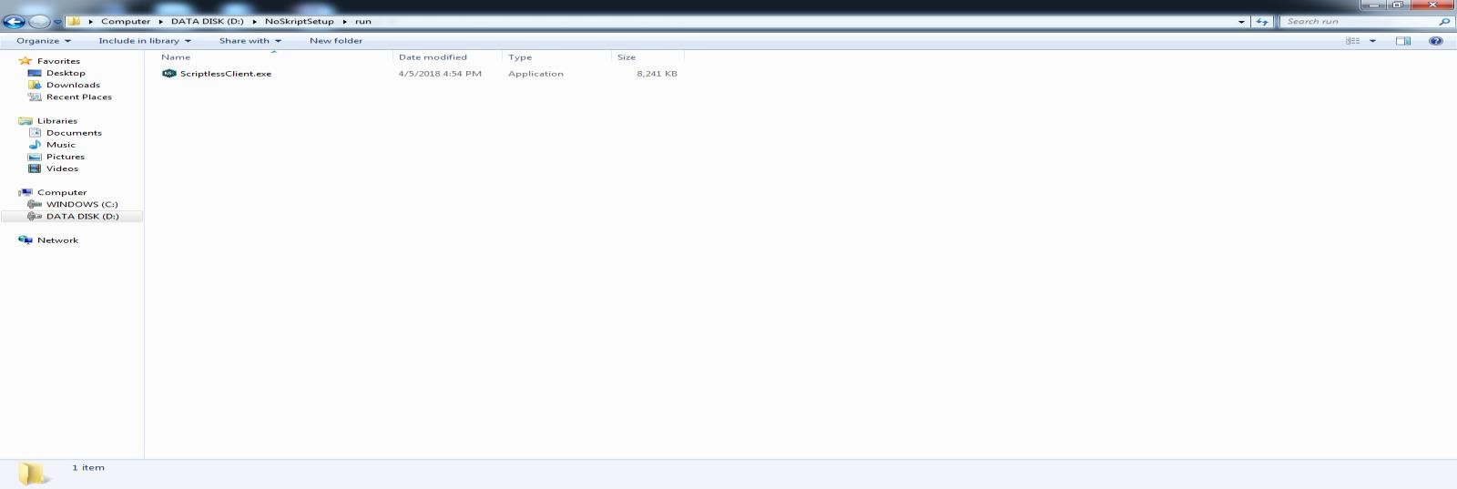

1. Create Folder (Eg: - named “demo”) on the location where you wish to install the NoSkript Client to run from as shown below.

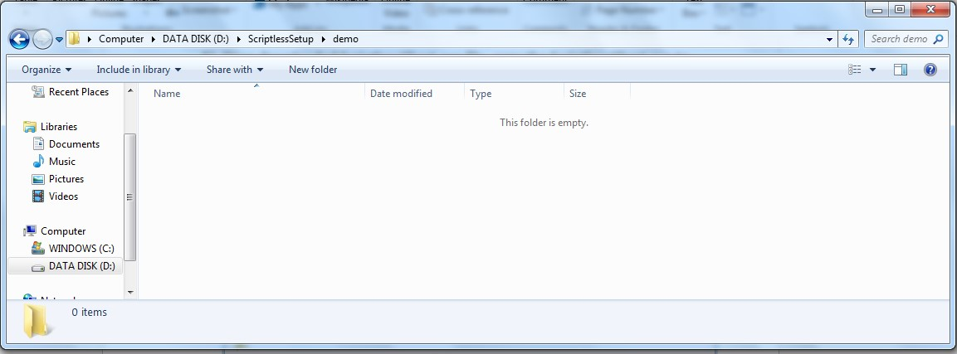

1. Now install NoSkript Client by clicking “ScriptlessClient.exe”. Once clicked, a UI screen is appeared as shown below.

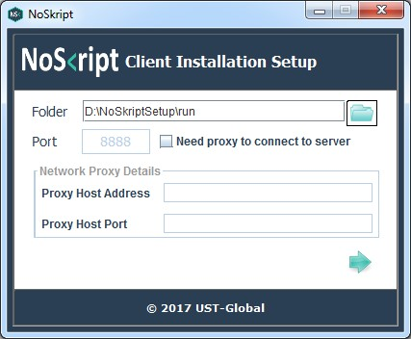

1. Choose the directory where you want to install the NoSkript Client Setup as shown below

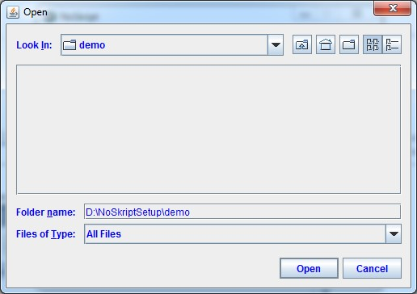

1. Click “open” button to select folder and Click “Next” button to continue as shown below

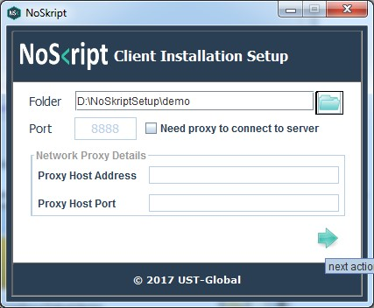

1. Once Clicked, the NoSkript Client Setup starts to download, install and configure as shown below

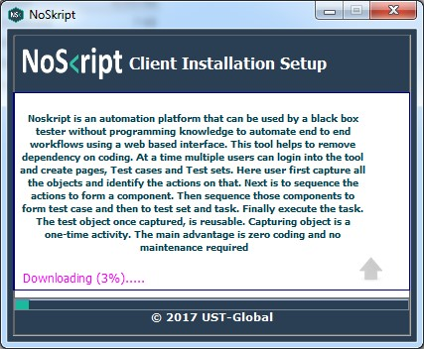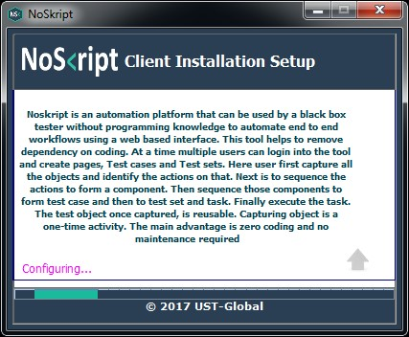

1. Once install is finished, the screen shows status “Starting the app” with a launch button. Click the launch button to complete the process or close the window.

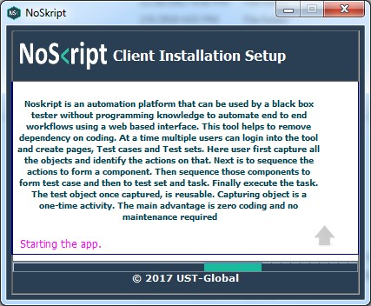

1. After the Successful installation of NoSkript Client Setup, a System tray icon would be seen as shown below.

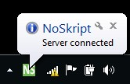

**Note: -** From Client side to work, Port 8888 need to be open so that NoSkript server and client can communicate to each other.

You can check that after seeing the “Server Connected” in tray icon by hitting client machine IP address in another machine. Example if client machine IP Address is 10.100.97.26, then type address [http://10.100.97.26:8888](http://10.100.97.26:8888/) in another machine which can be pinged to this machine as shown below.

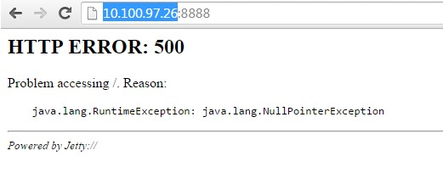

SELENIUM – GRID SET UP:

1. Create folders jars and generatedFiles next to scriptlessclient folder

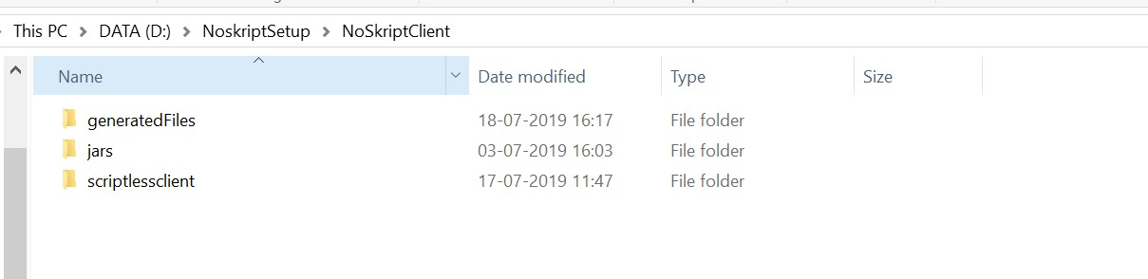

1. Download required jars from these paths

<https://noskript.heb.com/setup/jars/testng>[-6.5.1.jar](https://noskript.heb.com/setup/jars/testng-6.5.1.jar)

<https://noskript.heb.com/setup/jars/selenium>[-server-standalone-3.141.59.jar](https://noskript.heb.com/setup/jars/selenium-server-standalone-3.141.59.jar)  <https://noskript.heb.com/setup/jars/selenium>[-remote-driver-2.53.1.jar](https://noskript.heb.com/setup/jars/selenium-remote-driver-2.53.1.jar)  <https://noskript.heb.com/setup/jars/selenium>[-api-2.53.1.jar](https://noskript.heb.com/setup/jars/testng-6.5.1.jar)

<https://noskript.heb.com/setup/latest/scriptless>[-client.](https://noskript.heb.com/setup/latest/scriptless-client)jar

1. Place in jars folder
2. Download attached folder and place it in drivers folder inside scriptlessclient folder

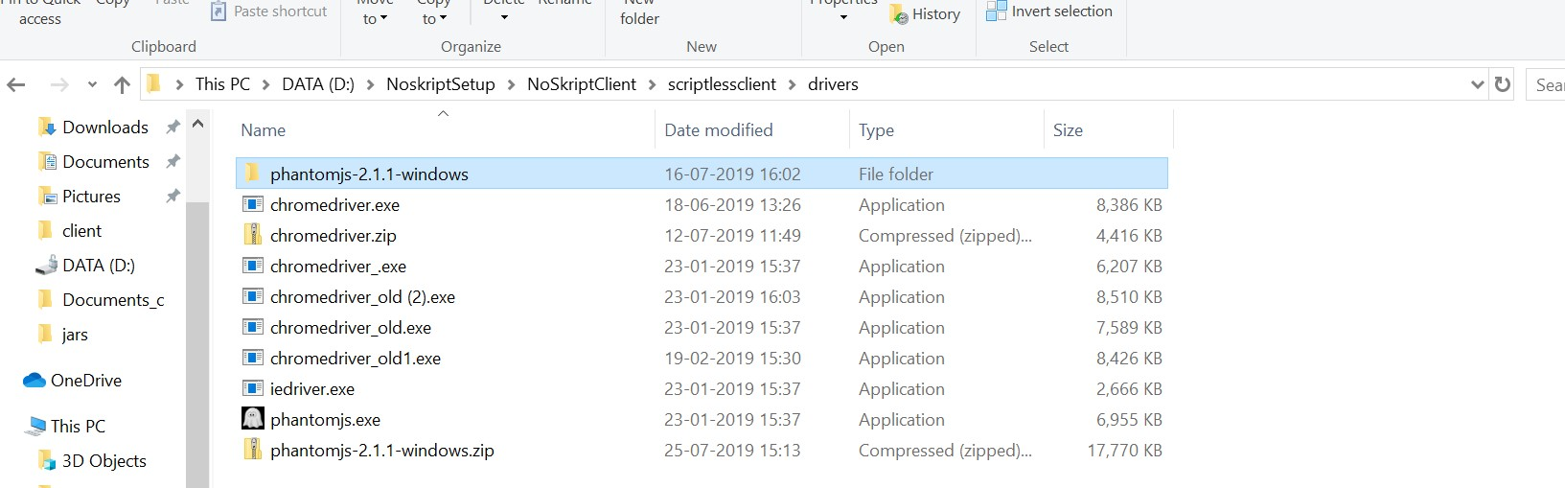



1. Edit conf.properties file and make below changes:

Example:

package.name =NoskriptSetup.NoSkriptClient.generatedFiles #(this is the folder structure)

destination.path.of.generated.files = D\:\\NoskriptSetup\\NoSkriptClient\\generatedFiles\\

# Paths for Dynamic TestSet Classes

javac.for.testset = javac -cp D:/NoskriptSetup/NoSkriptClient/jars/testng-

6.5.1.jar;D:/NoskriptSetup/NoSkriptClient/jars/selenium-api-

2.53.1.jar;D:/NoskriptSetup/NoSkriptClient/jars/selenium-remote-driver-

2.53.1.jar;D:/NoskriptSetup/NoSkriptClient/jars/scriptless-client.jar;.

# Paths for DynamicTestSuit class javac.for.dynamictestsuit = javac -cp D:/NoskriptSetup/NoSkriptClient/jars/testng-

6.5.1.jar;D:/NoskriptSetup/NoSkriptClient/jars/scriptlessclient.jar;

D:/NoskriptSetup/NoSkriptClient/generatedFiles;. phantomjs.driver.path=D:/NoskriptSetup/NoSkriptClient/scriptlessclient/drivers/phantomjs-

2.1.1-windows/phantomjs-2.1.1-windows/bin/phantomjs.exe

1. Open command prompt and navigate to jars folder

Run below command to start hub :

java -Xmx1024m -jar selenium-server-standalone-3.141.59.jar -role hub

1. Open command prompt and navigate to jars folder

Run below command to start node :

java -Dwebdriver.chrome.driver=<Chrome Driver path> -jar selenium-server-

standalone-3.141.59.jar -role node -hub http://localhost:4444/grid/register -browser "browserName=chrome, maxInstances=3, seleniumProtocol=WebDriver"