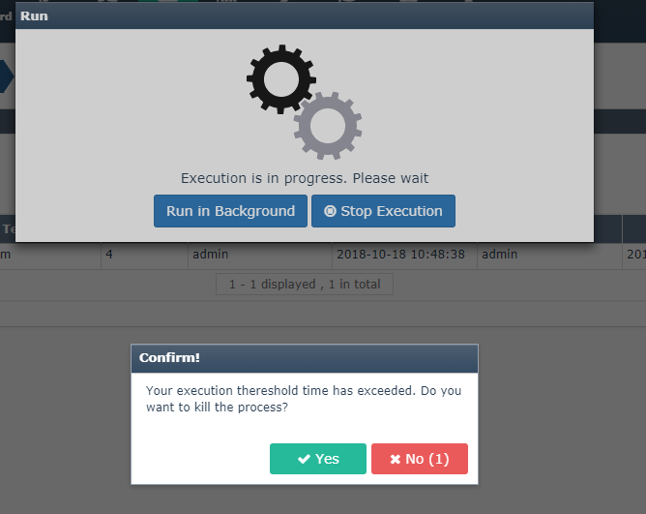

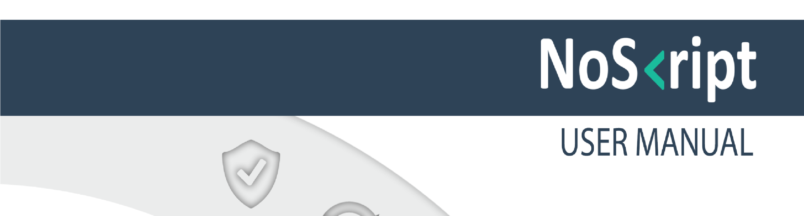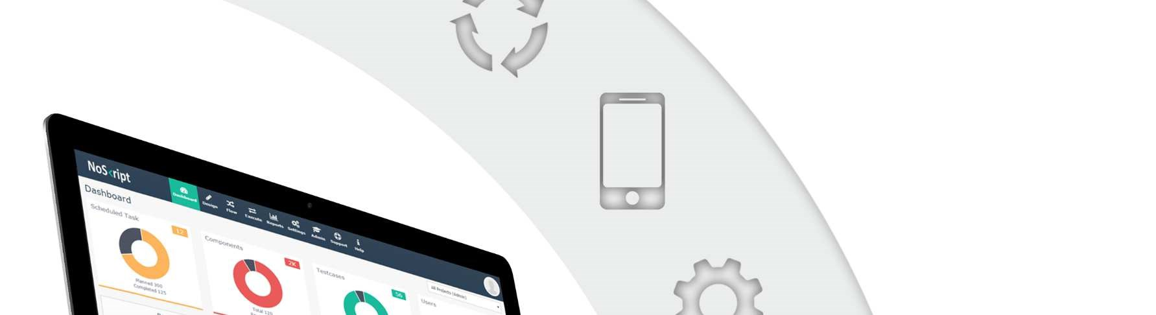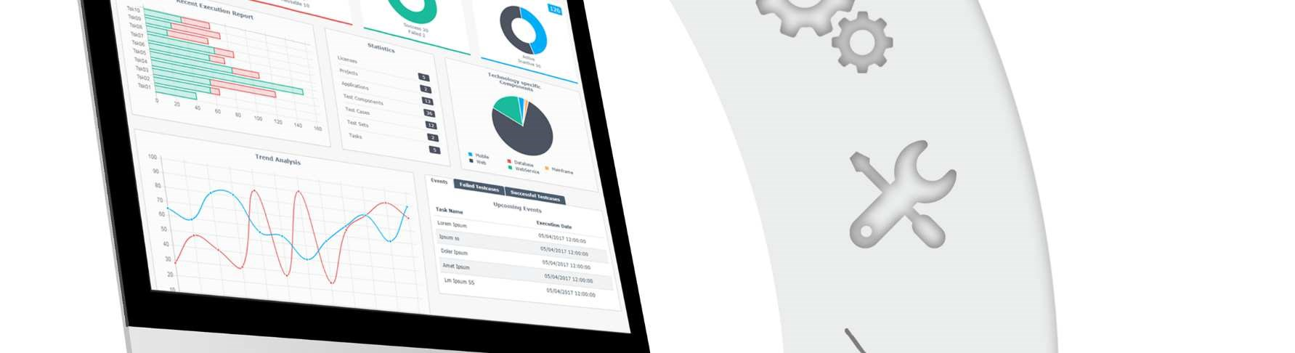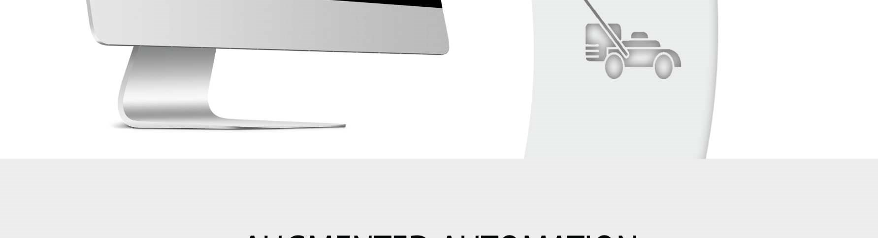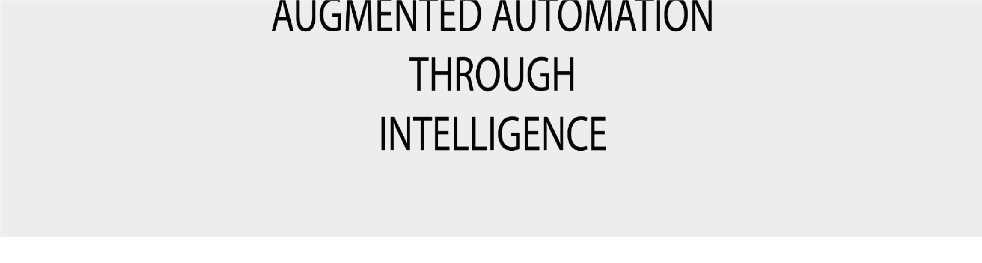

**Document Revision History**

|  |  |  |  |  |
| --- | --- | --- | --- | --- |
| **Rev #** | **Date** | **Updated by** | **Reason for Update** | **Status** |
| 0.1 | 5/04/2016 | Rajalekshmy | Initial Template | Draft |
| 0.2 | 7/08/2017 | Rajalekshmy | Update On New UI | Draft |
| 0.3 | 23/05/2018 | Swathy P K | Update on Technology and Encryption Rules. | Draft |
| 0.4 | 31/10/2018 | Arundhathi.B | Update on killswitch | Draft |

**Contents**

1 INTRODUCTION 3

1.1 APPLICATION OVERVIEW 3

2 BENEFITS OR FEATURES 3

3 SCREENS IN THE NOSKRIPT AUTOMATION TOOL 4

3.1 **LOGIN SCREEN** 4

**ADMIN TAB** 6

3.1.1 Manage Users 7

3.1.2 Manage Projects 9

3.2 **DESIGN** 14

3.2.1 Page 16

3.2.2 Test object 17

3.2.3 Test Step 21

3.2.4 Test Component…………………………………………………………………………………25

3.3 **TESTFLOW……………………………………………………………**27

3.3.1 Test Case 28

3.3.2 Test Set 35

3.4 **EXECUTE** 36

3.5 **CHARTS AND GRAPHS** 42

3.6 **WEBSERRVICE**…………………………………………………………………………………………………….47

3.7 **COMMANDLINE**………………..………………………………………………………………………………….53

3.8 **DATABASE**…………………………………………………………………………………………………………56

3.9 **MOBILE**……………………………………………………………………………………………………………..62

3.10 **ENCRYPTIONRULES**……………………………………………………………………………………………..66

3.11 **KILLSWITCH**...........................................................................................................................................................70

3.12 **DBPUTTY**…………………………………………………………………………………………………………..73

3.13 **MULTI TESTSET**………………………………………………………………………………………………….74

# Introduction

## Application Overview

Noskript is an automation platform that can be used by a black box tester without any programming knowledge to automate end to end workflows using a web based interface. This removes the dependency of experienced automation testers in the team.

At a time multiple users can login into the tool and create pages, Test cases and Test sets.

Here user first capture all the objects and identify the actions on that. Next is to sequence the actions to form a component. Then sequence those components to form test case and then to test set and task. Finally execute the task. The test object once captured, is reusable. Capturing object is a one-time activity. The main advantage is zero coding and no maintenance required.

# Benefits or Features

* Zero dependency on programmers to design scripts.
* Plug and Play Automation Tools.
* Generate automation scripts 40% faster .
* Automate test cases spanning across multiple channels –web and mobile.
* Reduces test script maintenance overhead .
* Kick Start Automation before User Interface is ready.
* 2 Levels of reusability – Test Step and Test Component Level .
* Support for remote execution of scripts .
* Cross browser and data driven testing support .
* Multiple levels of reporting – Test Case , Test Component and Test Step Level .
* Live Report using Charts and Diagrams .

# Screens in the Noskript Automation Tool

## Login screen

In the Login Screen, User is able to enter the Username and Password to access the application.

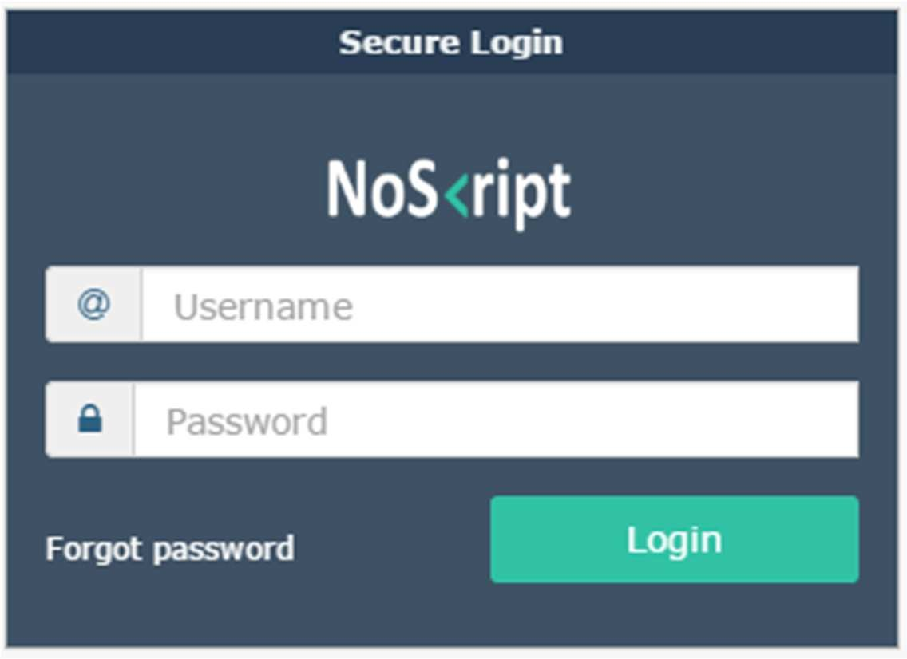

After login, user is redirected to the Dashboard page with the following options

1. Dashboard
2. Design
3. Flow
4. Execute
5. Reports
6. Settings
7. Admin

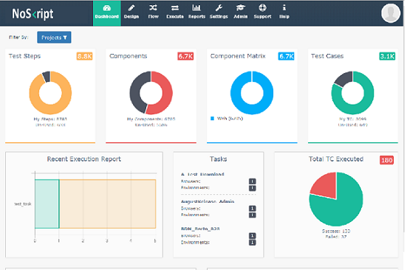

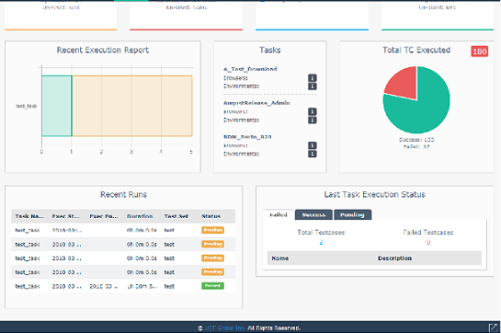

**Admin Tab**

Only an admin user can view the admin tab. Admin has the following privilege

Mange user

Manage Project

Machine Lab

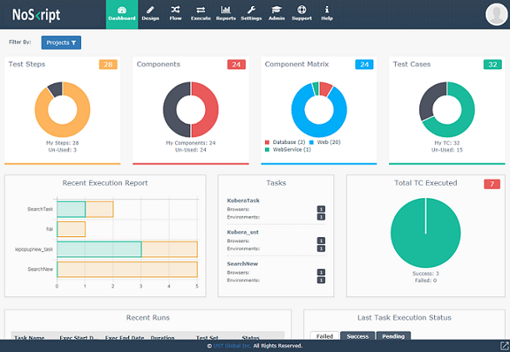

### Manage Users

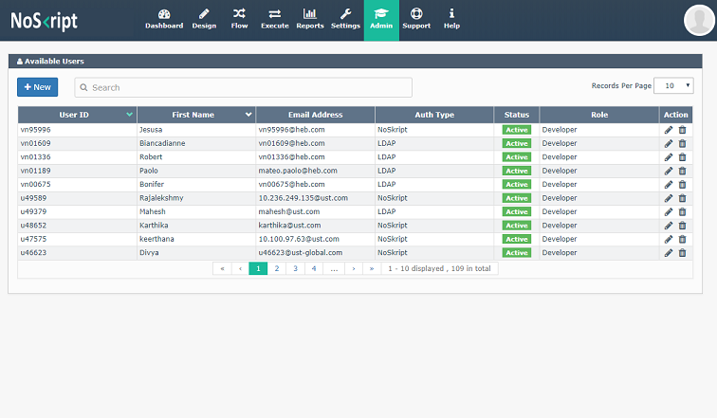

On clicking the ‘**New’** button, admin can create a new user. Create New User screen is as below. Admin can also modify and delete any user.

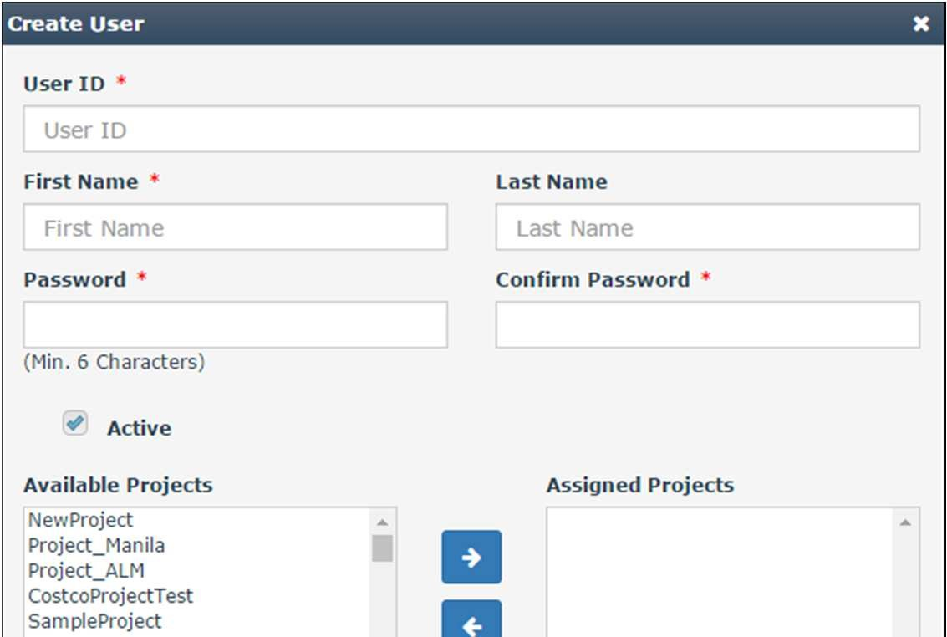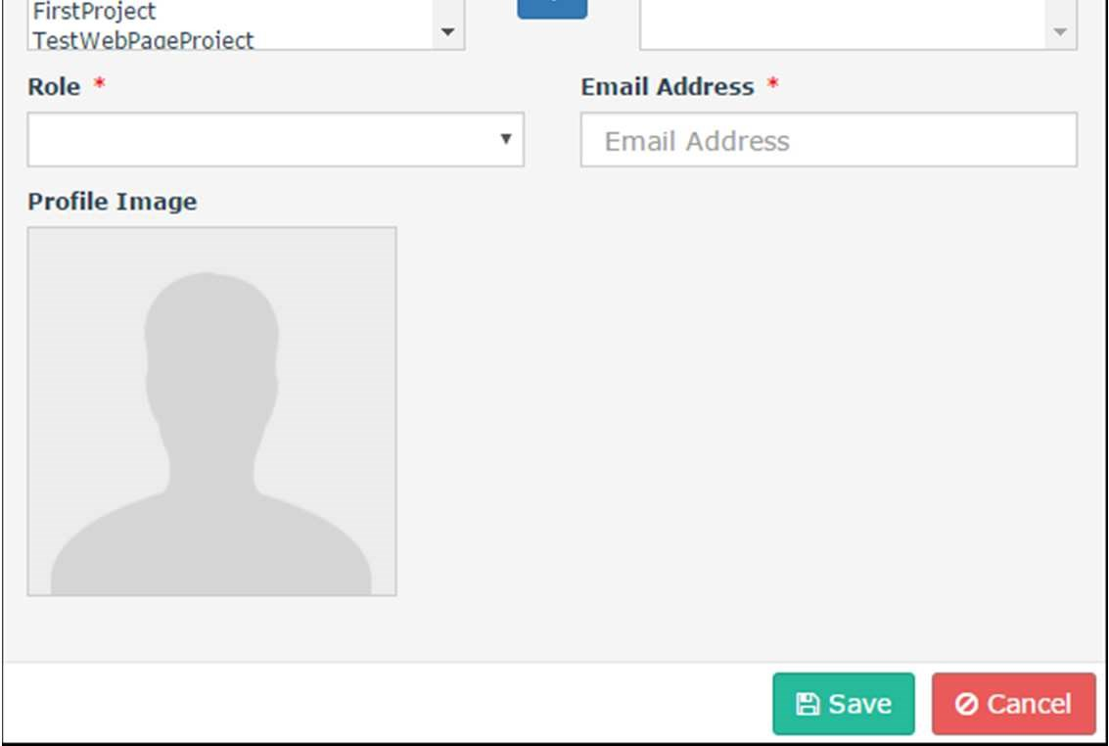

Admin can assign role to each user based on the privileges required. There are mainly 4 roles, in addition to Admin

* Manager
* Developer
* Executor
* Viewer

**Manager, Developer**: Users with these roles can do all operations except admin specific operations (like manage users, manage projects, deletion of records)

**Executor**: An executor can view all the screen except admin and also can execute the test sets.

**Viewer**: Viewer can only view the screens (except Admin tab).

### Manage Projects

The provision for creating“New Project” is available under Settings 🡪Project Settings.

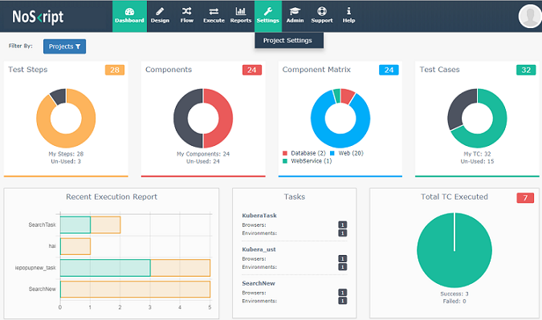

On Clicking on the ‘**Project Setting**’, the below screen is displayed, Where admin can create, edit and delete project.

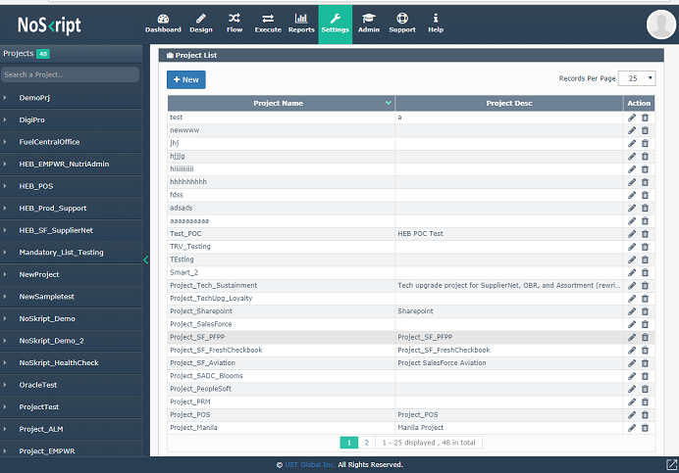

**Create Project:** Click ‘**New**’ Button, below screen gets displayed

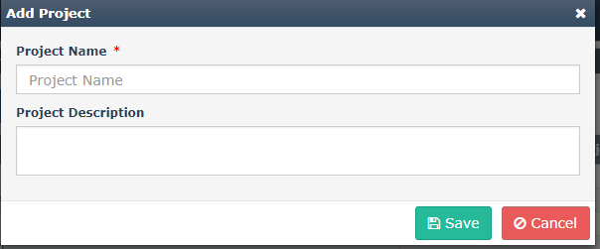

* Enter project name
* Enter project description
* Click save

Created projects are listed under ‘**Project**’ grid and clicking on any one of the project display the information of project under ‘**Project Details**’. Admin only have the privilege to edit and delete the project.

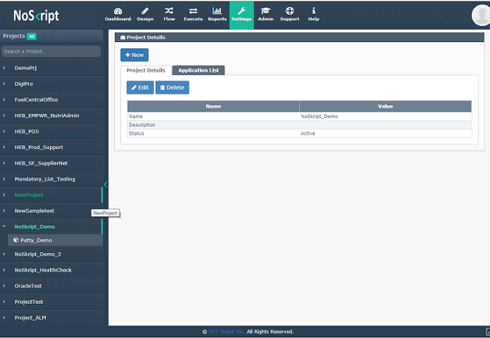

**Create Application**: By clicking on ‘**Application List**’ tab, shows the Application created for that project. Click **‘NEW**’ button, where admin can create a new application.

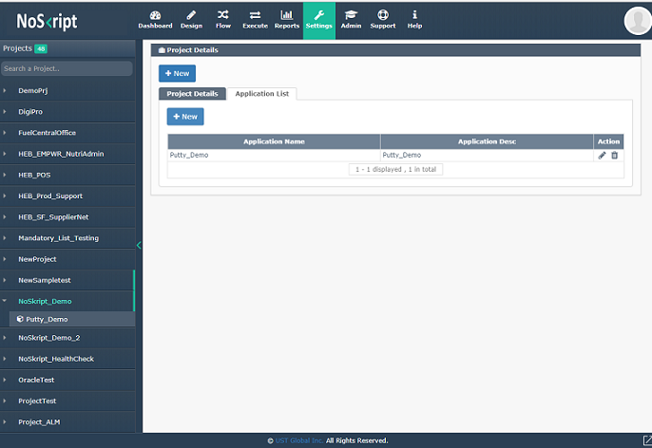

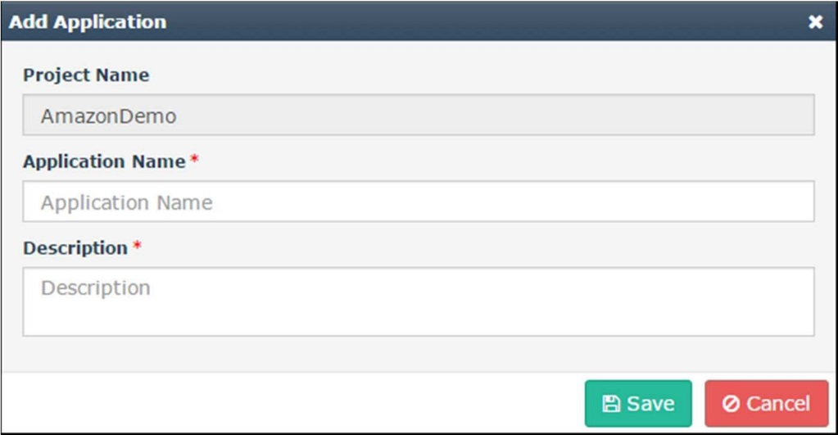

* Enter application name
* Enter description
* Click save

**Create Environment**: Click project name under projects Application name. Application information gets listed under ‘**Application Details**’. Under ‘**Environment**’ tab have the provision to create environment.

Screenshots are as below:

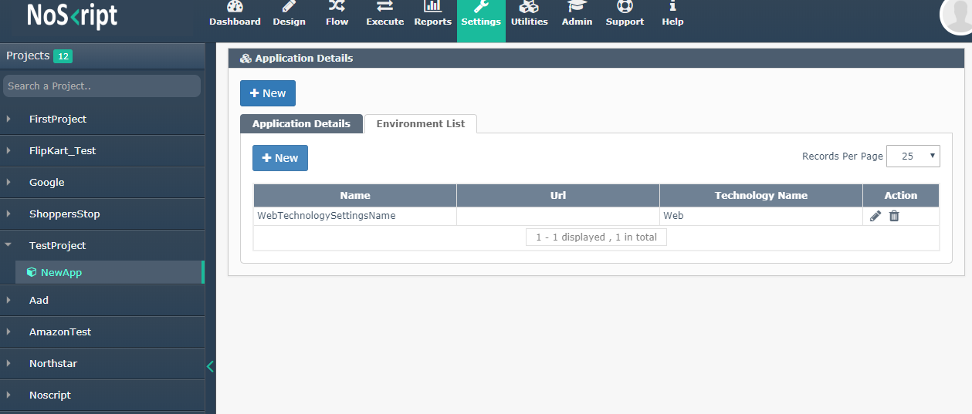

## DESIGN

The initial phase of creating the workflow is “Design”. Here we will create the replica of all pages belongs to the application, by capturing all the controls, associate actions for that controls and sequence it. Design consist of following steps:

* Pages
* Test Object
* Test Step
* Test Components

To start with, click Design tab and choose your project then application and then technology.

Screenshots are as follows:

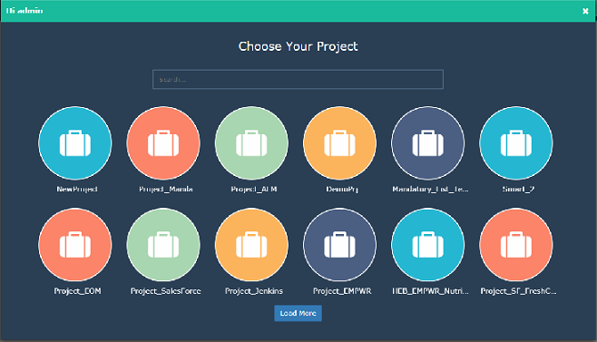

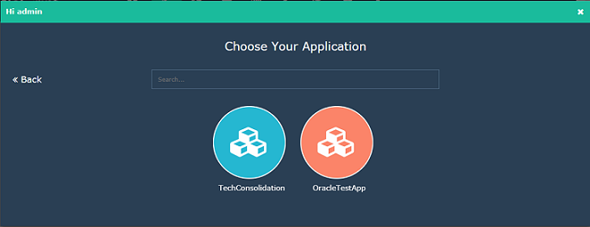

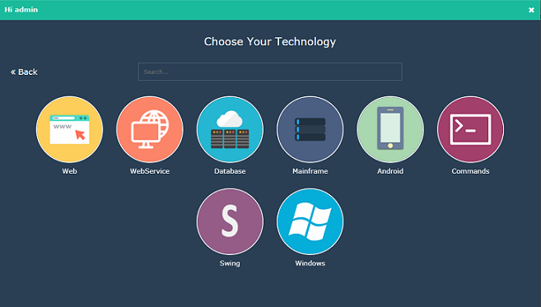

### Page

Split the workflow/ scenario into number of modules for the ease of usability. Below example shows how to split a workflow.

**Scenario**: Login in to a commercial site, search and checkout a product and logout. The pages will be

* Login
* Search
* Add to cart
* Logout

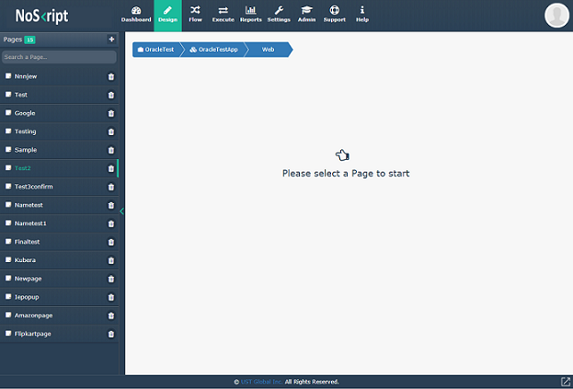

**Create a New Page:** By clicking on the ‘**+**’ icon, a dialog box gets prompted to create page. Enter the page name and click save, which will be listed under ‘**pages**’.

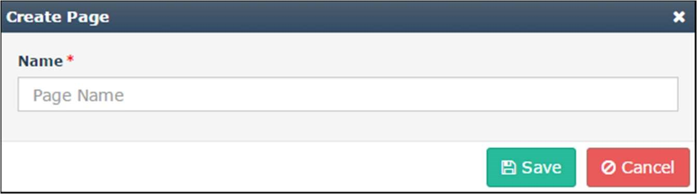

### Test object

Test object tab is used for capturing all controls such as objects. For example, in “Login page”, the controls email address, password fields and login button are objects.

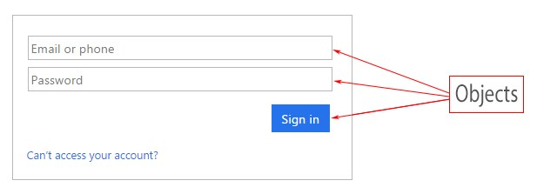

**Add an Object**: Click on the ‘New’ button, dialog window displayed in the screen as shown below for adding a neW object.

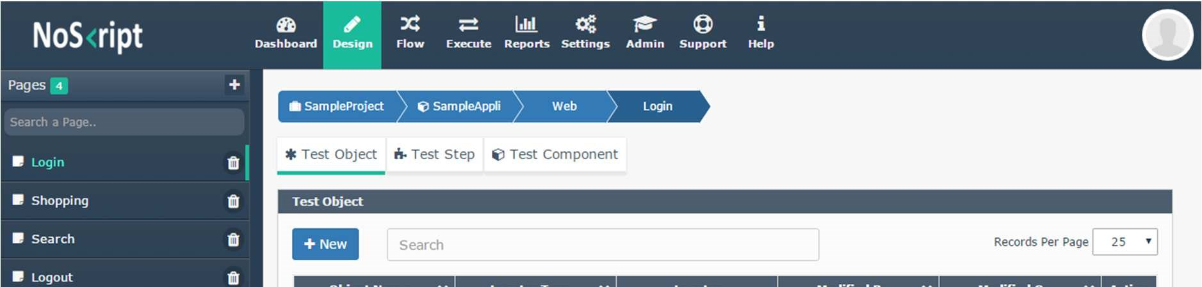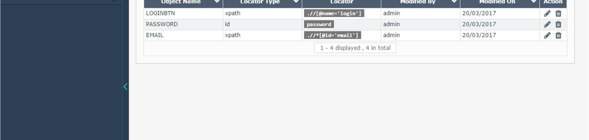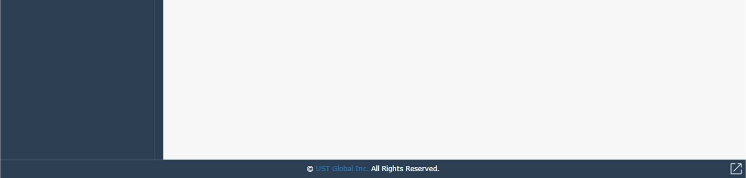

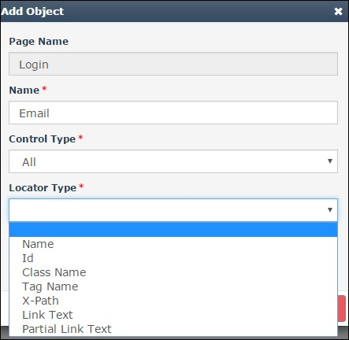 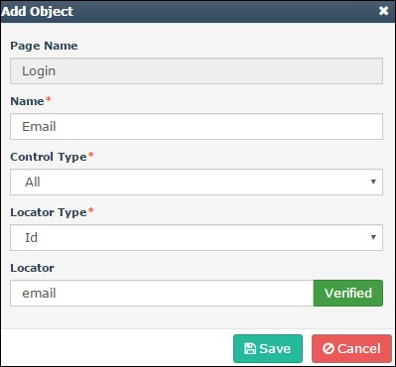

Enter Object Property Name – This is a text box and User can give meaningful name here

Enter Locator Type – Locator Type is a drop down and have the following lists.

* ID
* Class Name
* Tag Name
* X-Path
* Link Text
* Partial Link Text

Enter Locator - Here based on the Locator Type selected, user can give the corresponding locator id of the object. If locator Type is ‘Xpath’, then locator id is **“ .//*[@id=’email ID’] ”** Click the ‘Verify’ button, the button label changed to ‘Verified’. Click the ‘Submit’ button.

**Using Dynamic Parameters in Locator**

In cases, where we have to use dynamic parameters in locator, please follow these methods. For eg. In the below screenshot, we will select locator for the first product as

***Xpath - //*[contains(text(),’UMBRELLA')].***

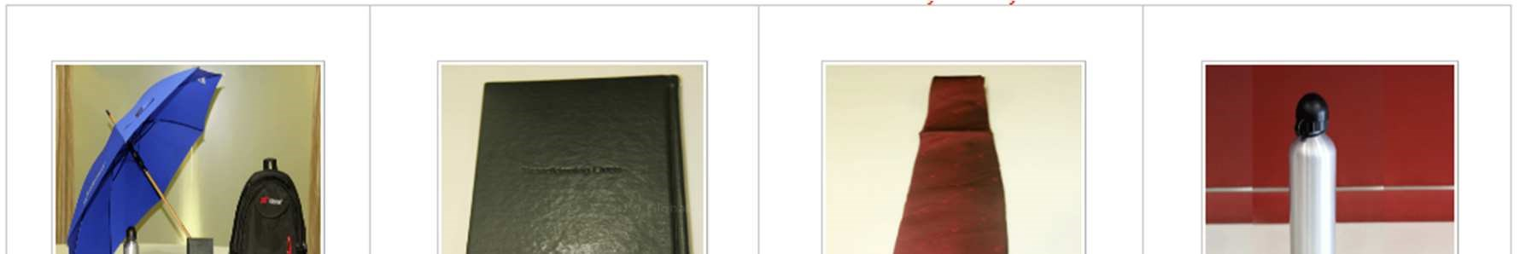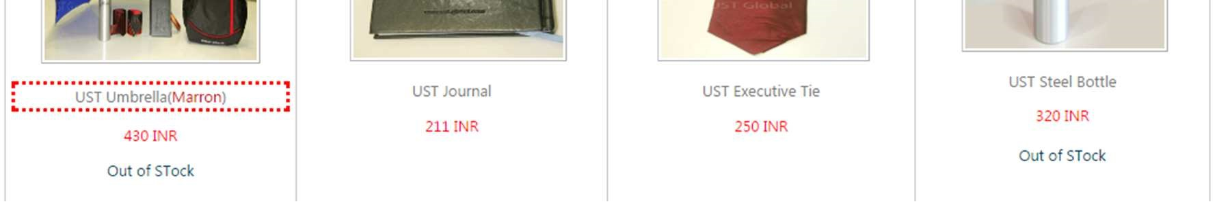

You can give the locator in a generic way using xpath //*[contains(text(),’%s’)] . On verifying the locator , text boxes will be displayed based on the count of dynamic parameters(%s), where the user can give any identifier keyword. In this example, (below screenshot) Object property name is **FinalProduct** and the field name is given as **name.** During the time of test case creation, on the screen where we add test data, it asks for a data **FinalProduct_name,** where the user can give the data as ‘**UMBRELLA**’, as per this example. User can change the data to locate to another product.

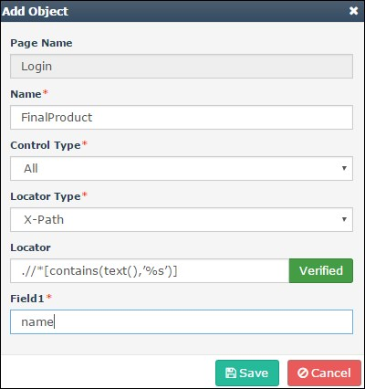

### Test Step

Associate action to perform on each object is identified in the test object. In order to create a Test Step, click ‘**New**’ button under test step.

Screenshots are as follows:

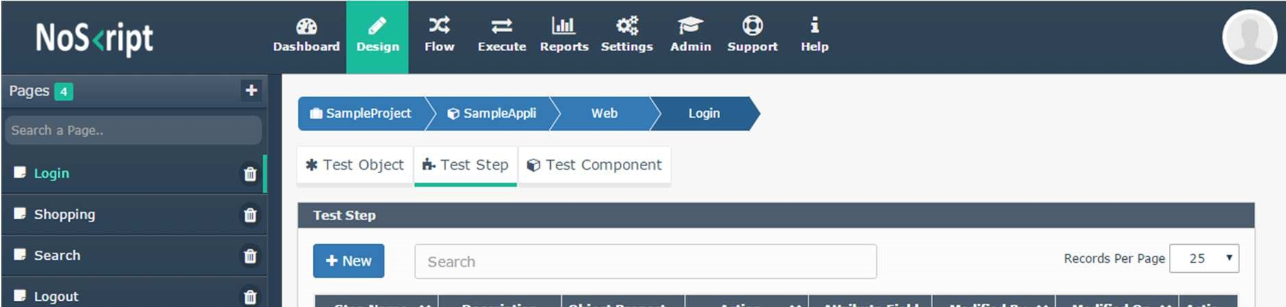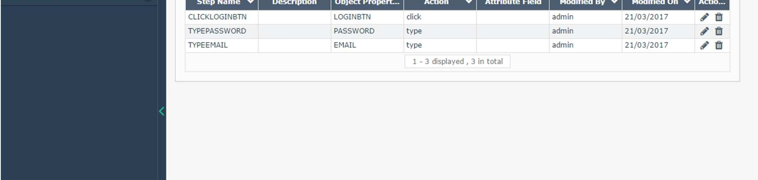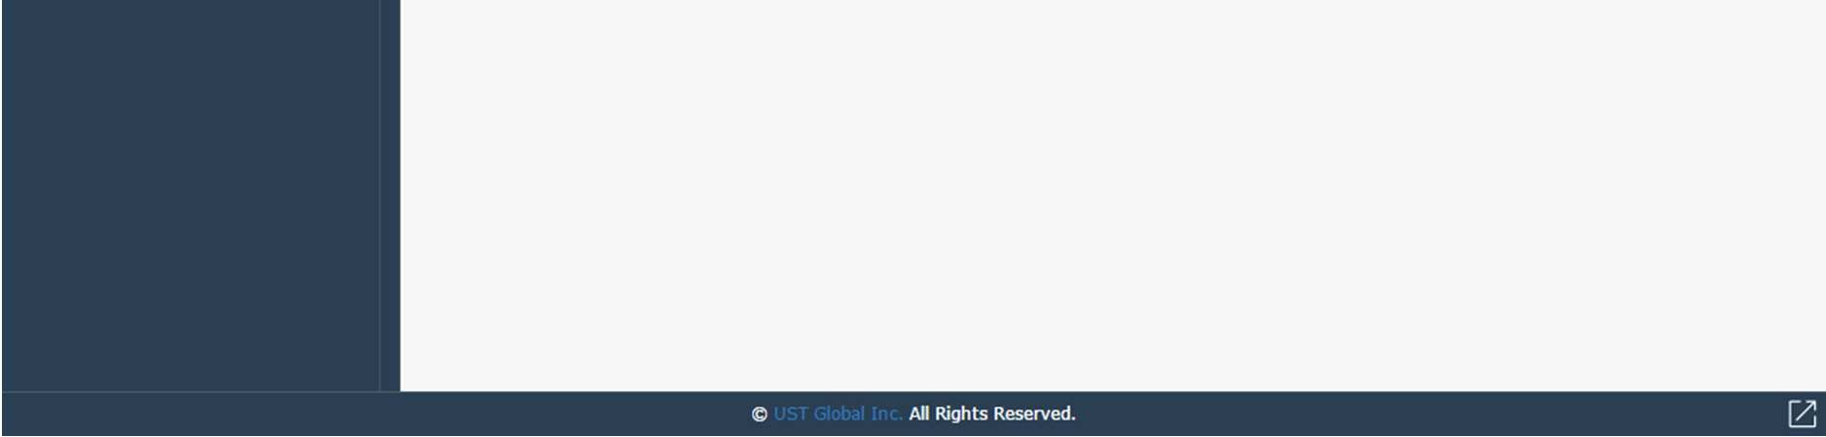

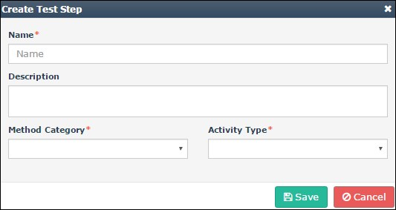

* + - * Enter step name
      * Enter the description
      * Select Method category
      * Default : Native methods provided by the tool
      * Custom : user defined methods

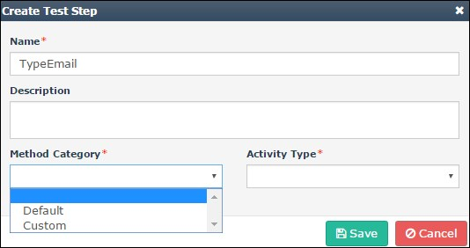

Select Activity Type

* Action
* Assertion
* Store

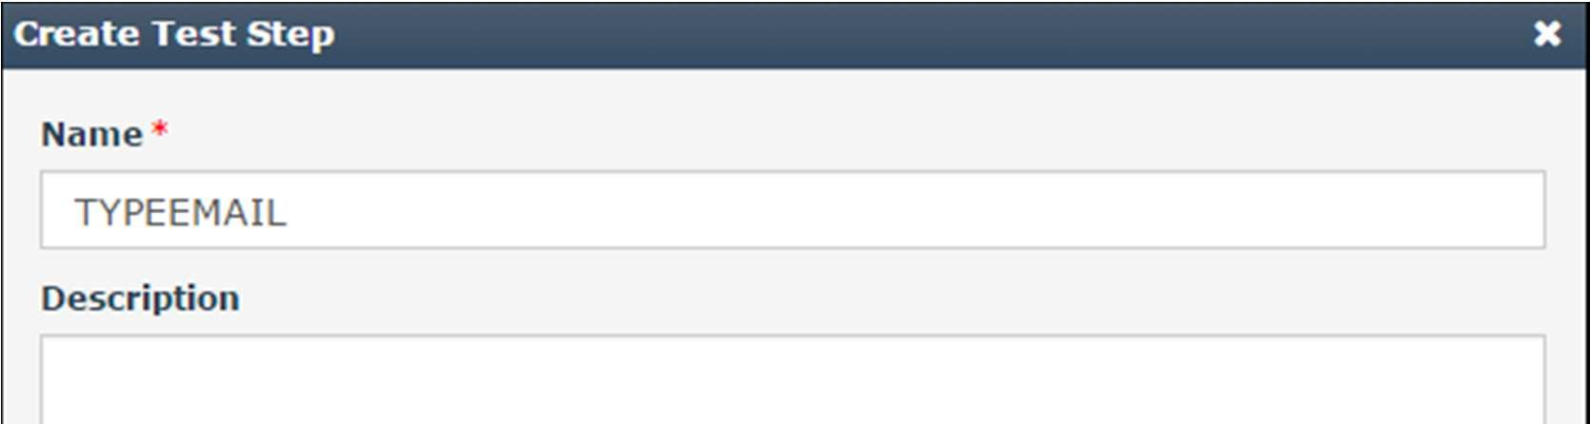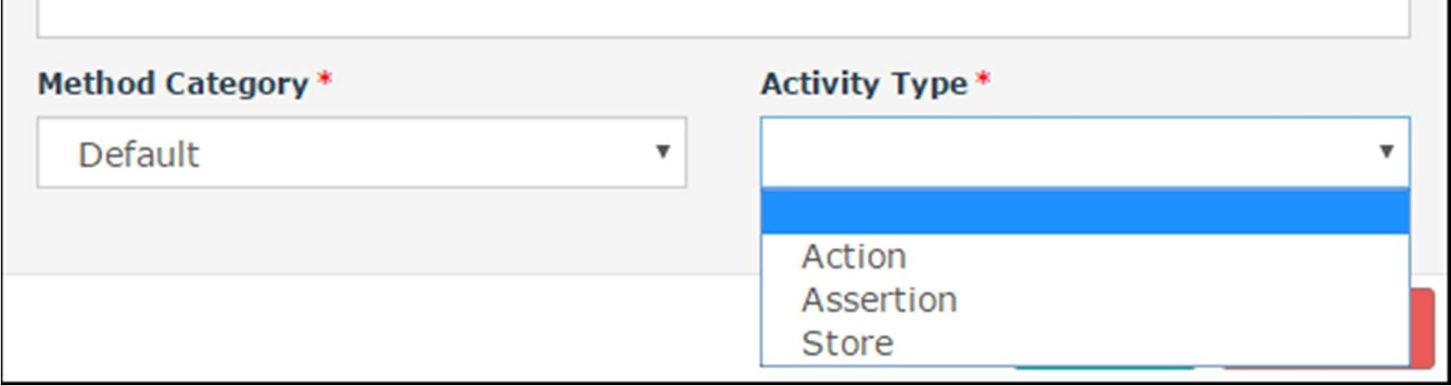

**Action**: All Generic controls are available under action. If the Activity Type selected is ‘Action’, then another ‘Select an Action’ drop down will display in the dialog window to select an action to the object identified in the Test Object. Once user select the ‘**Action**’ from the drop down, ‘Action subtype’ and ‘Select an Object’ dropdown displayed in the screen. This drop down list out all the objects identified previously in the Test Object tab.

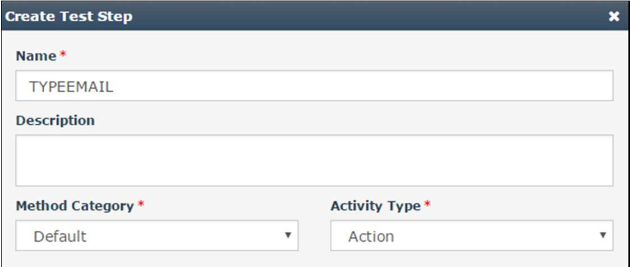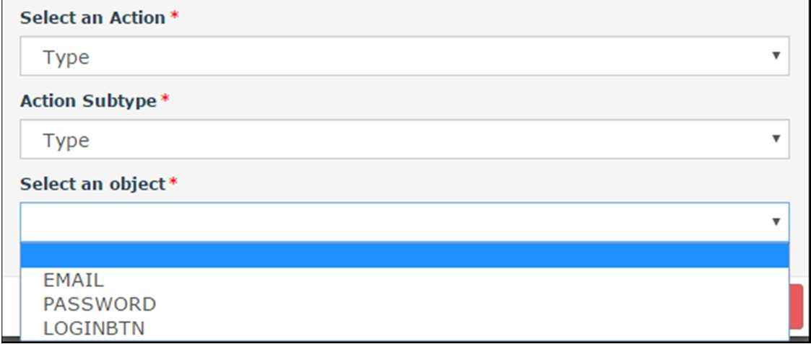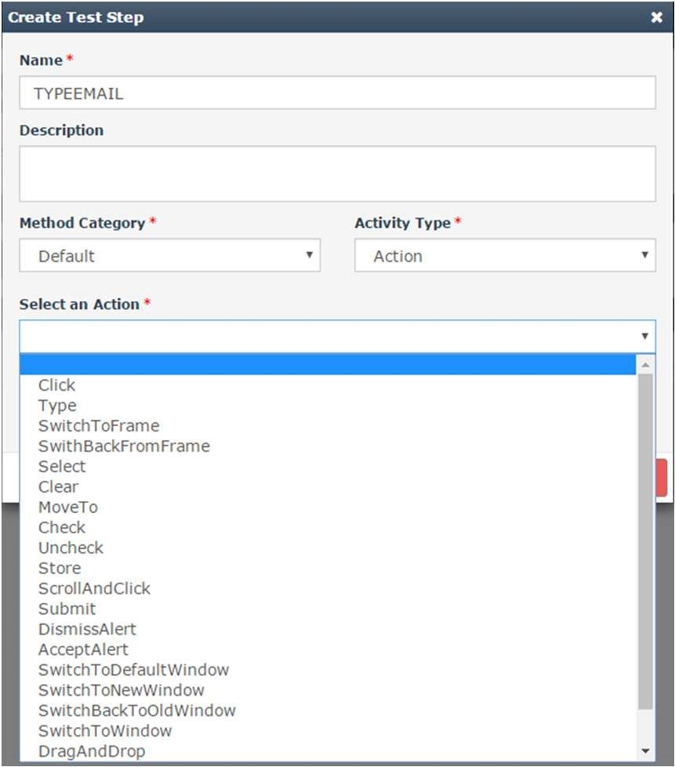

**For Upload:** select action and action sub type as ‘upload’.

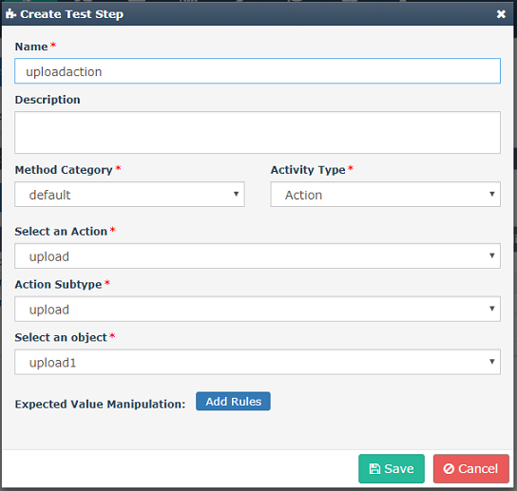

**Assertion**: Used for verifying any property, text in a workflow. If user select the Activity Type as

‘Assertion’, then ‘Select an Assertion’ drop down displayed in the screen to select an Assertion. Once user select the ‘Assertion’ from the drop down, then ‘Select an Object’ drop down displayed in the screen. This drop down list out all the objects identified previously in the Test Object tab.

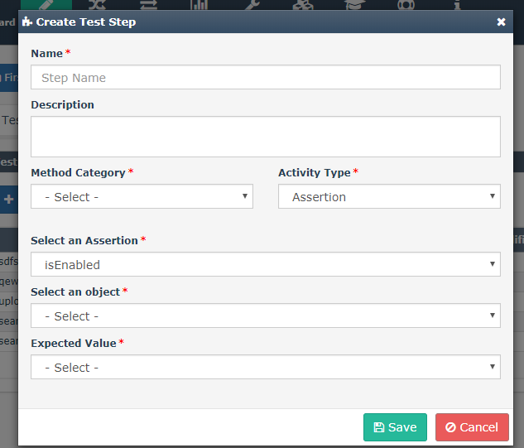

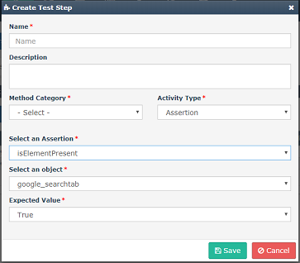

Select the Expected Value from the Drop Down and Click the Save button.

Also, we can verify a property (text , href etc.) using Assertion Verify Property, where user has the provision to enter which property to be verified and what should be the expected result( True or False). The value for the property can be given as a data at the time of test case creation.

**Store:** Used tostore a dynamically generated value which can be used for the later period in the same workflow. We can map the value to an object during test data creation.

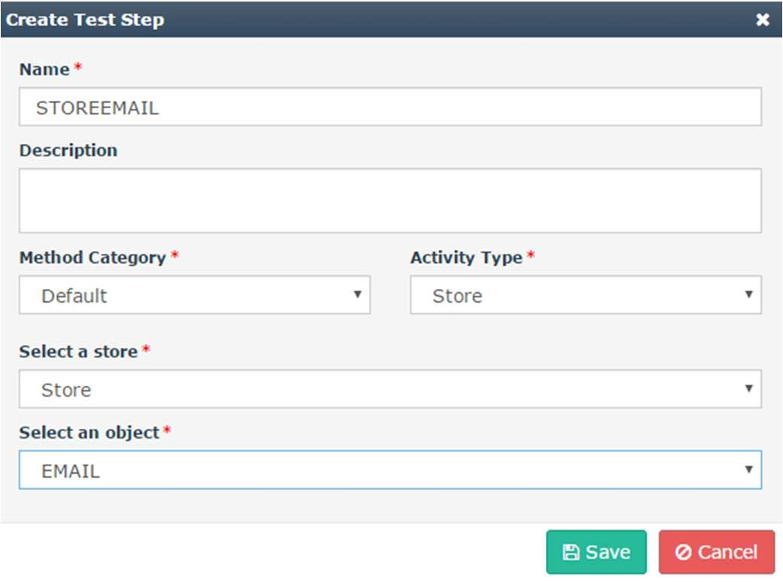

### Test Component

Once all Captured Objects are associated with actions, then sequence the test steps (actions) in the

Test Component tab. All the Test steps are reusable. Click ‘**New**’ to create component. Screenshots are as below

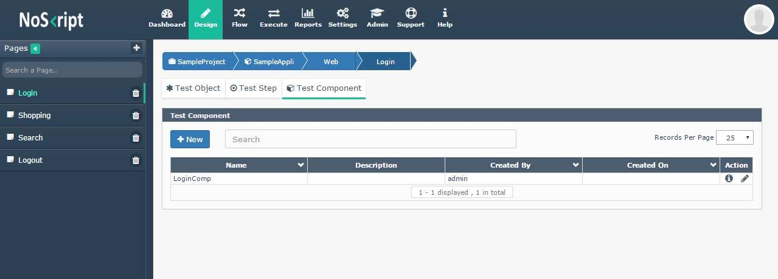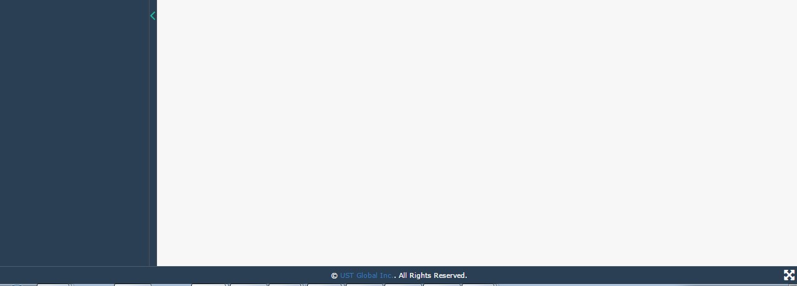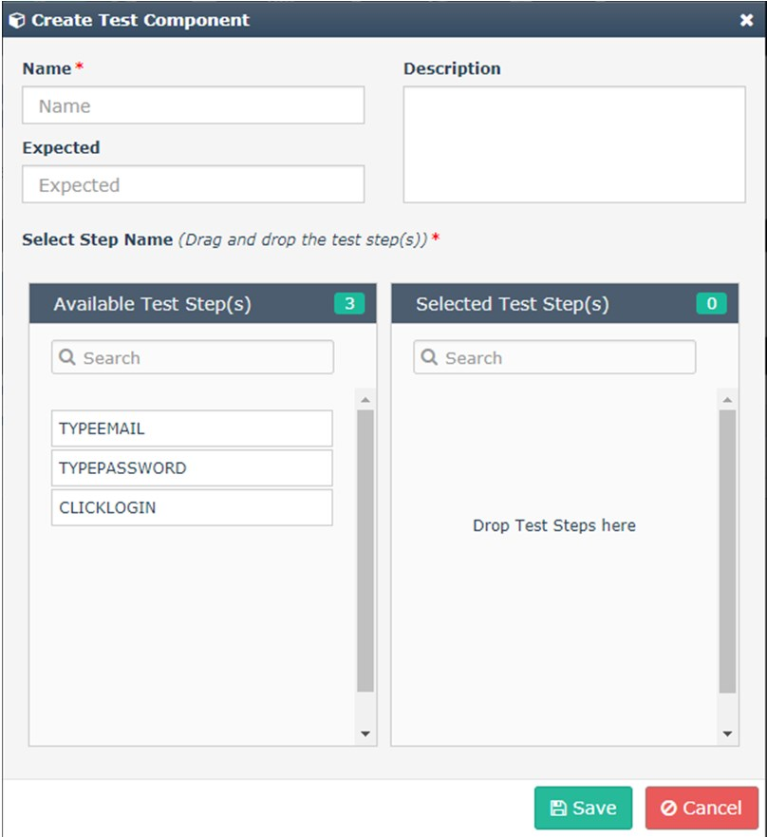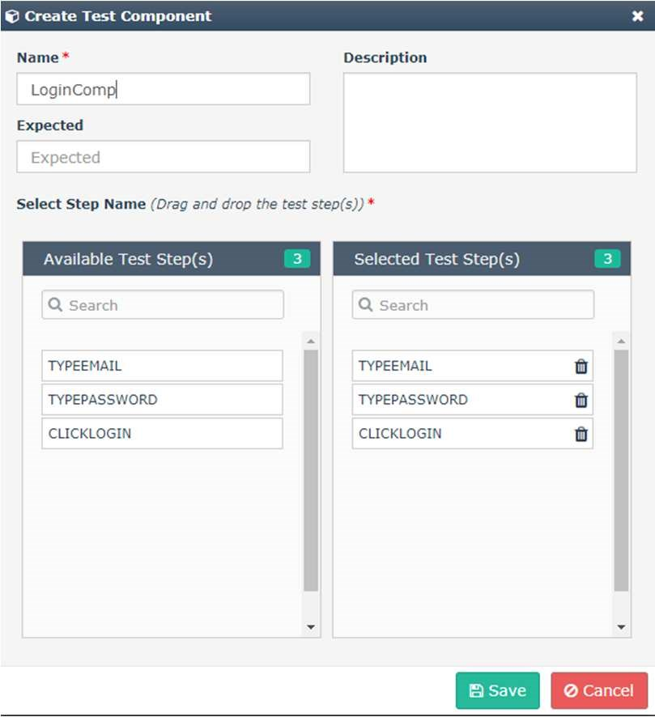

* + - * Enter Test Component name.
      * Drag and drop the Step name from the ‘Available Test Step’ list to ‘Selected Test Steps’ in sequence order.
      * Click save.

## TESTFLOW

The second phase of creating workflow is Test Flow, available in “Flow” tab of Noskript. Flow consists of

* Test Case
* Test Set
* Test Data

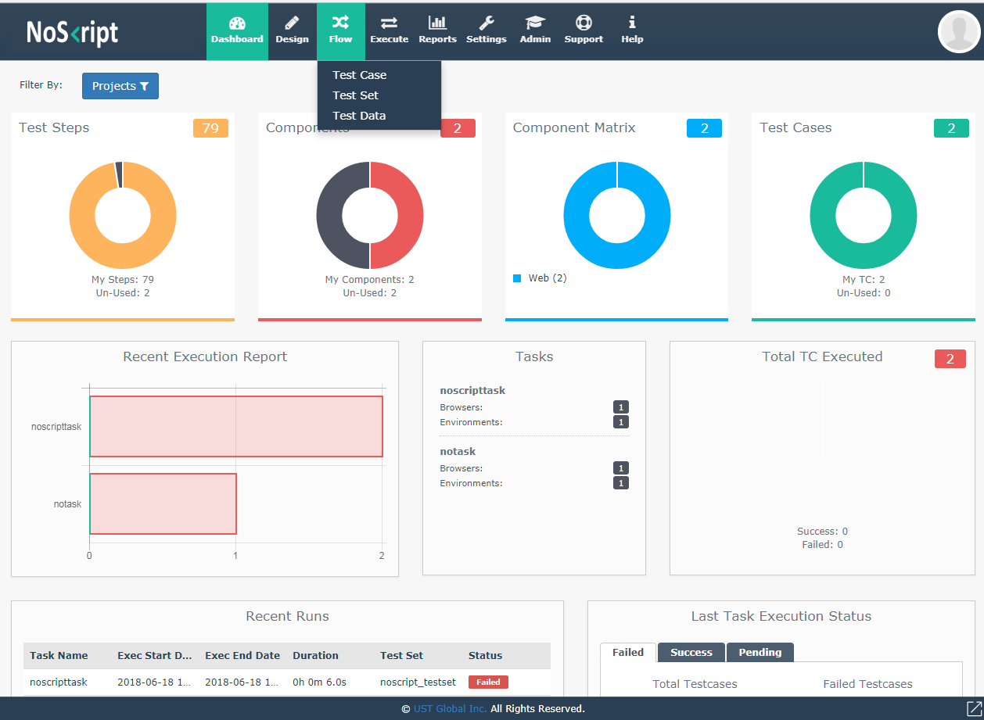

### Test Case

Once the Test Components are ready, user is able to create Test Cases .Testcase is bundled with single or multiple “**Sequence**” but should contain one sequence at least. A sequence is a combination of multiple components from different pages of different technologies. Click the ‘Testcase’ listed under flow tab.

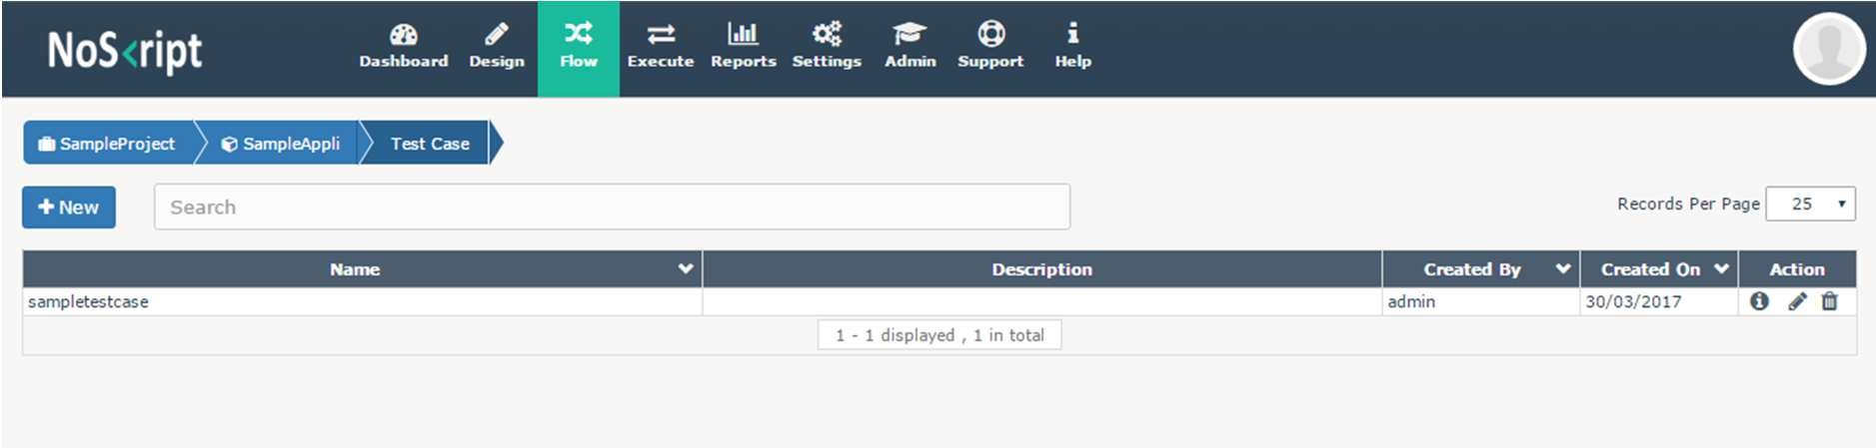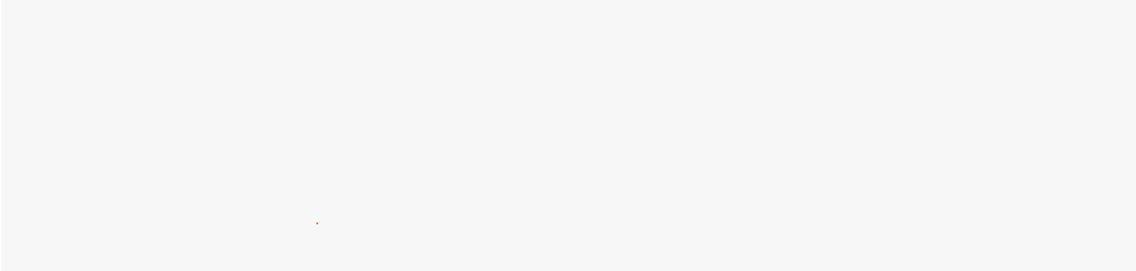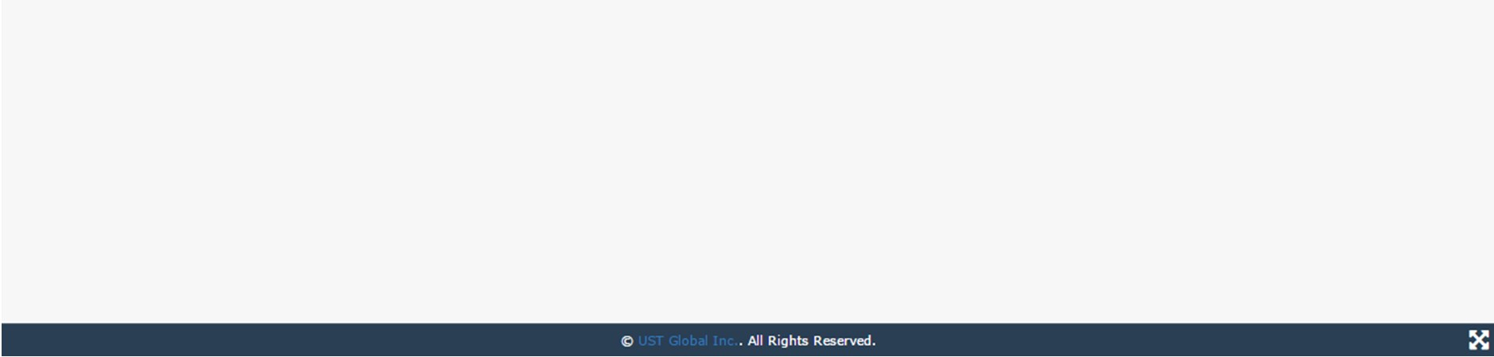

**Create Test Case**:

* Click the ‘NEW’ button.
* A default sequence is created
* Click ‘Add’ button under test component for adding component to that sequence.
* Select the components listed under different pages of different technologies.
* Click ‘Add’ button.
* Selected components are listed under ‘**Test Components**’

Screenshots are as follows

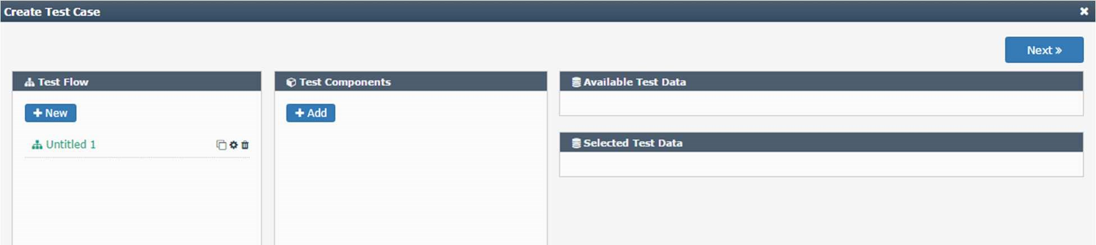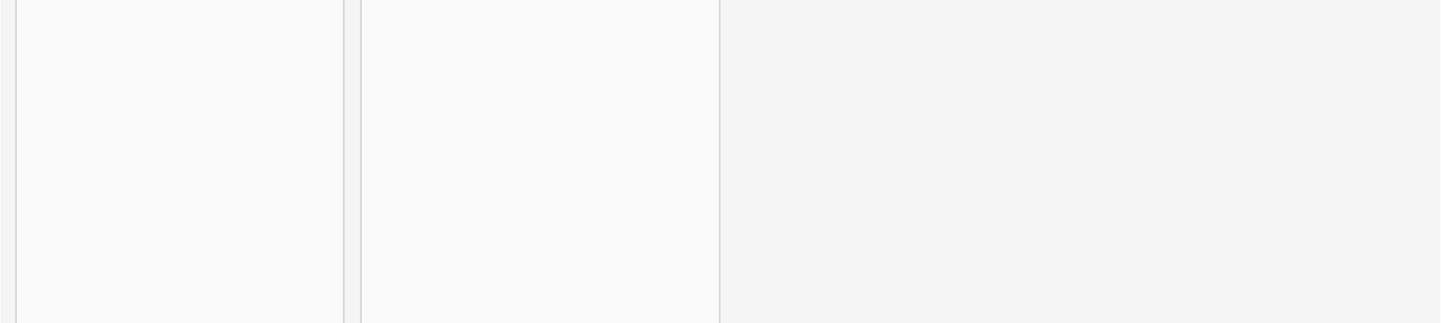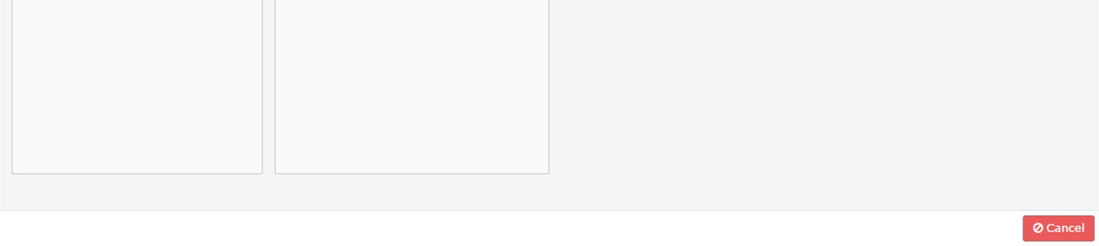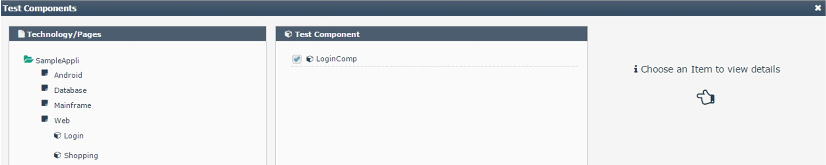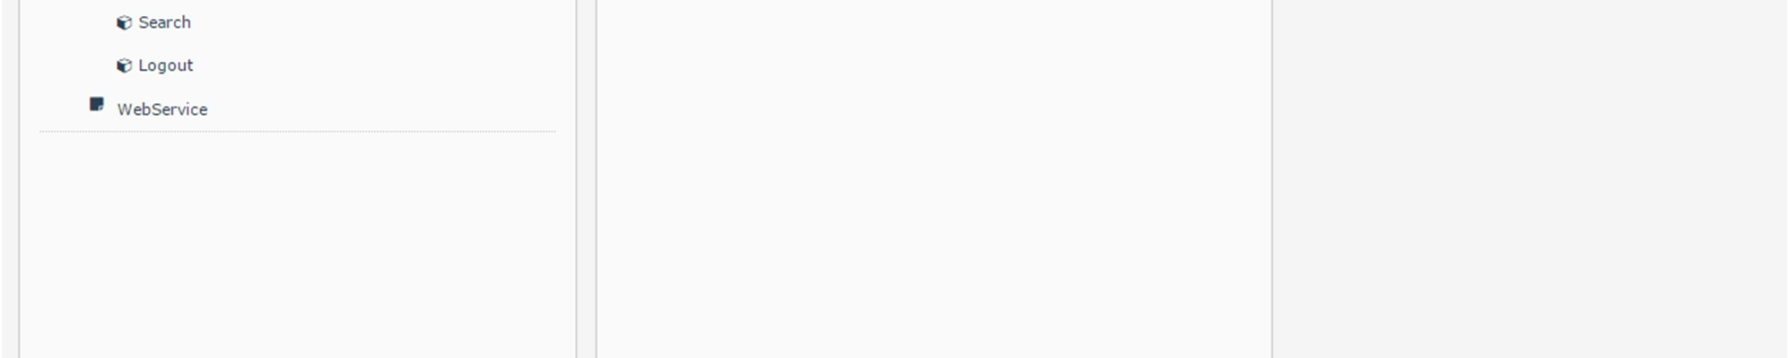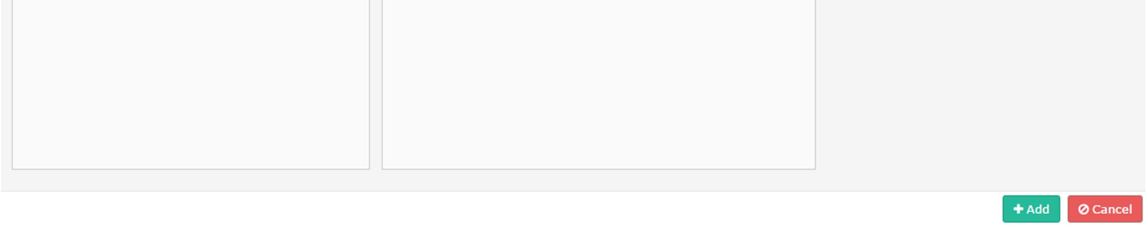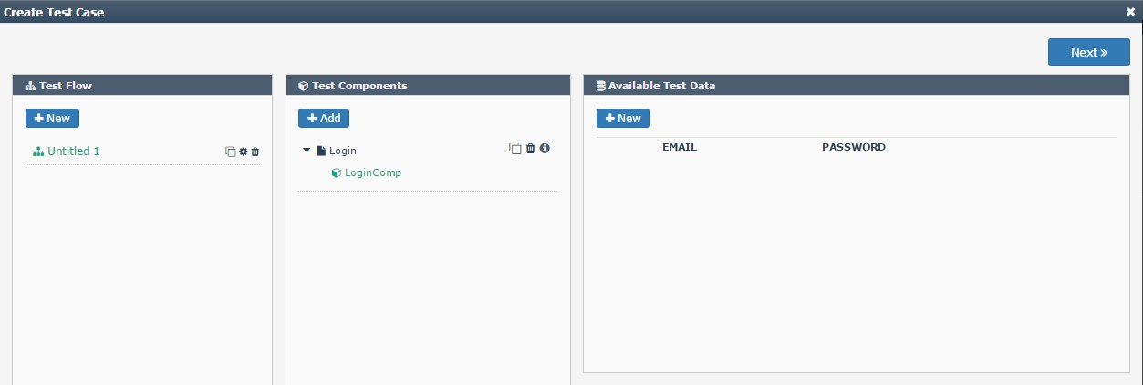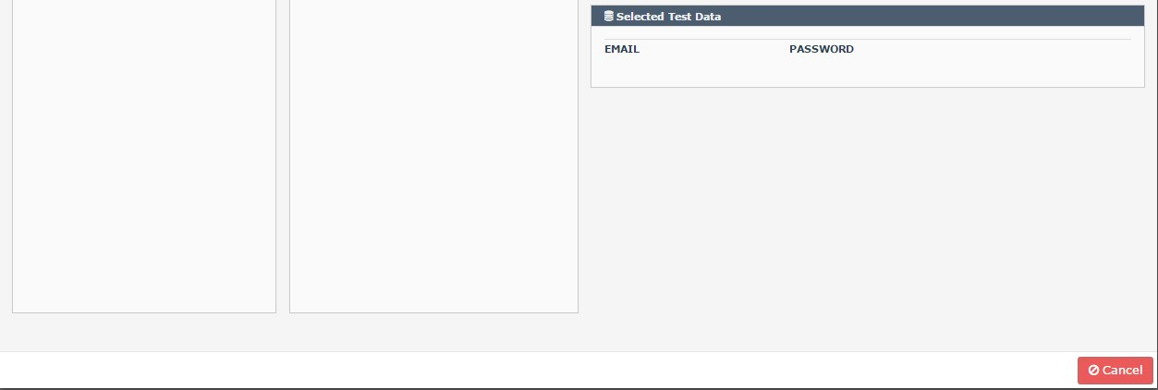

**Create New Sequence**: Click ‘**New**’ under ‘**Test Flow**’ grid to create a new sequence. Once the sequence is created, add components to the sequence as mentioned above. We can perform copy, modify and, delete operations for a sequence. Also we can rearrange the created sequence in any order. We can associate n number of sequences to a test case where each sequence may be a combination of different components.

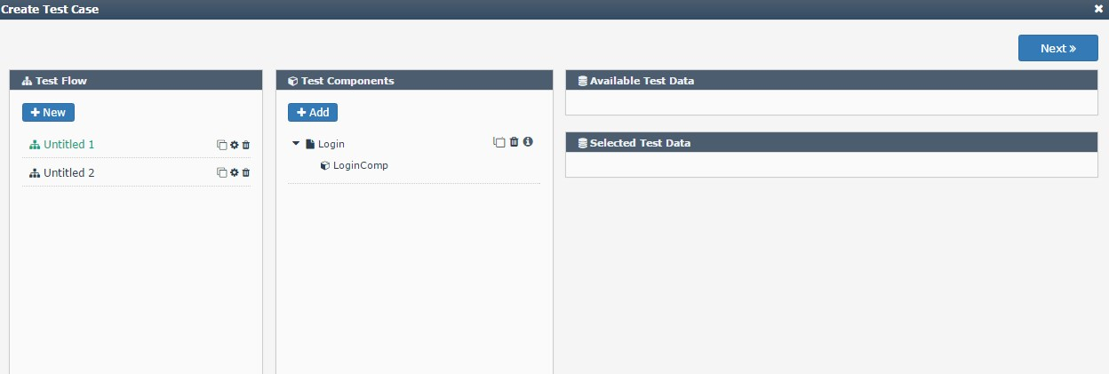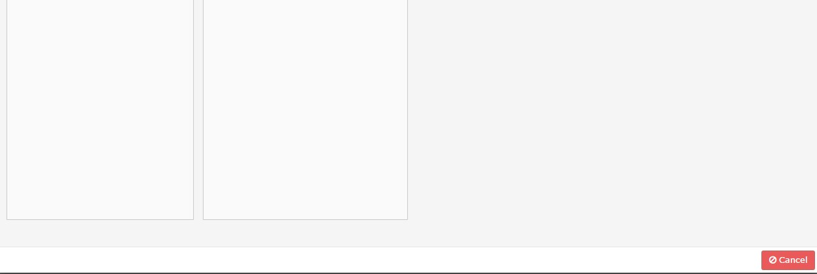

**Add Test Data:** Once the components are selected for each sequence, next step is to associate test data for all components that requires input. Click ‘NEW’ under ‘**availability test data**’ grid. Then input textbox will be enabled where user can the data and click add button. It is possible to add n number of Test Data. Click the ‘+’ icon to move the test data downwards which is used for the current execution. After associating test data, click ‘**Next**’ button. Screenshots are as below

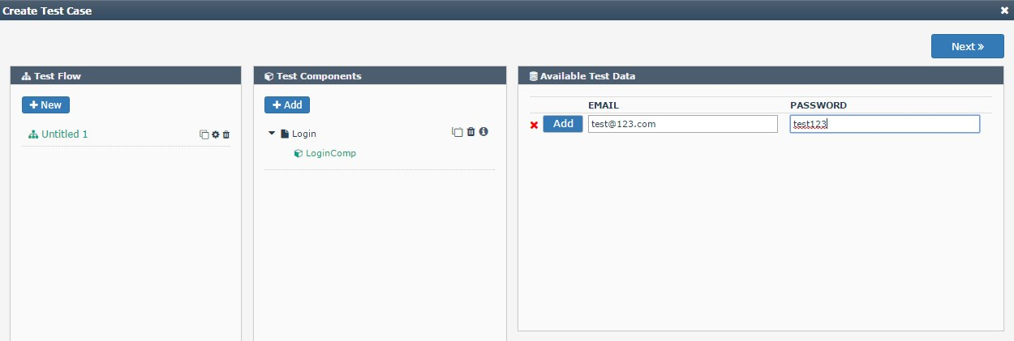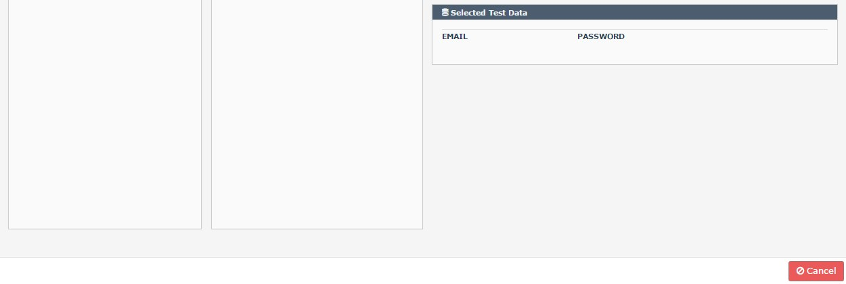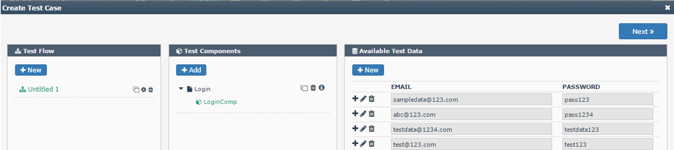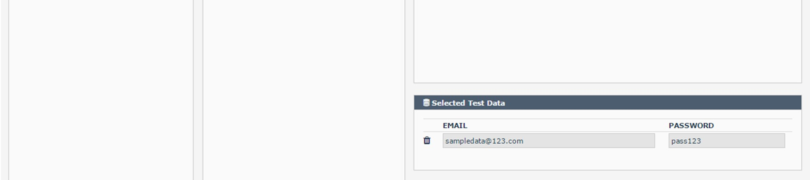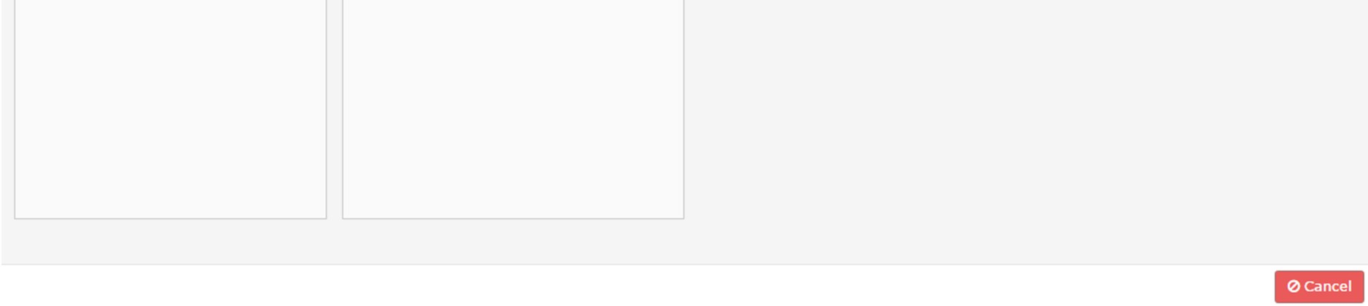

**FOR UPLOAD:** If we select action type as ‘**upload**’ then test data will be in the given format.

C:/Users/Public/Pictures/Sample Pictures/Chrysanthemum.jpg

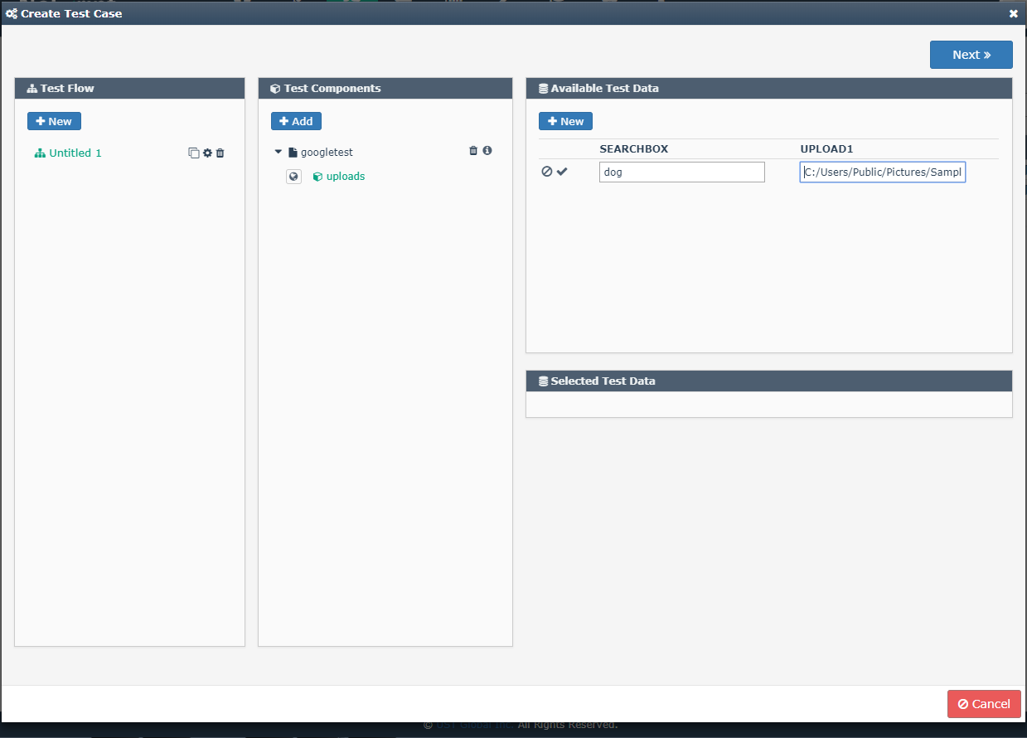

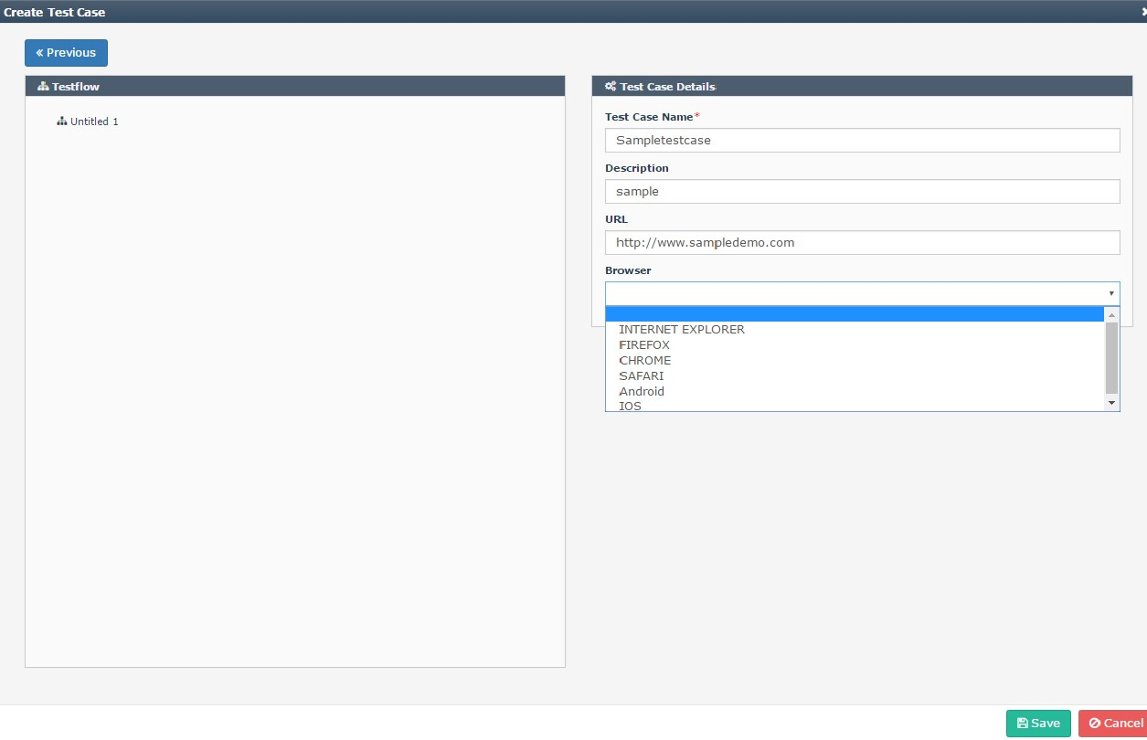

* + - * Enter Test Case Name
      * Enter the description
      * Enter the URL
      * Select the Browser from the drop down. Following Browsers are available in the drop down
  + Chrome
  + Firefox
  + Internet Explorer
  + Safari
  + Android
  + IOS
* Click save

If you want to do the execution on mobile platform, you can select browser as Android or IOS.

**3.3.2 Test Set**

Once the Test Cases are ready, user is able to create Test Sets. It is possible to create Test sets with more than one test cases. The entire workflow design is completed after creating the test set. Click ‘Test set’ listed under flow tab. For creating a test set, click ‘**New**’ button

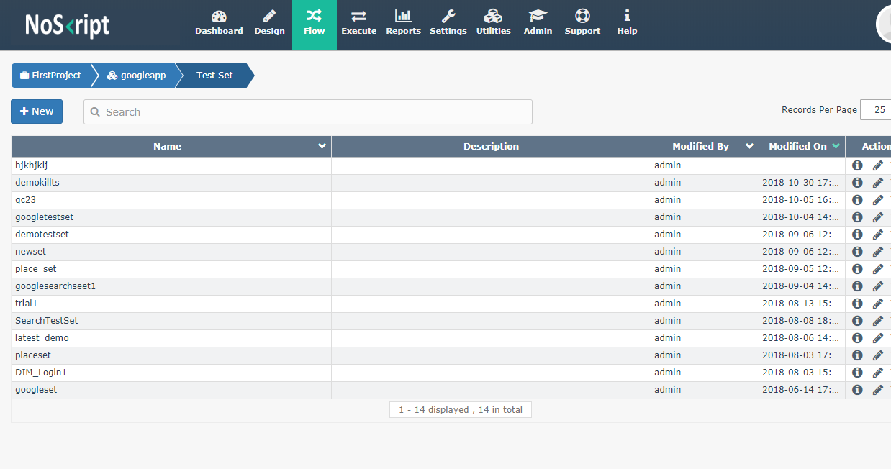

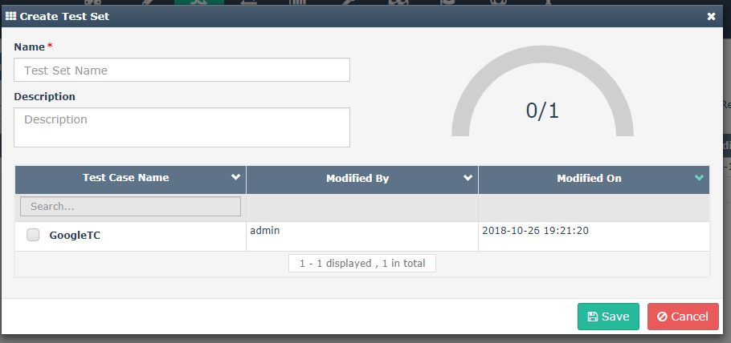

* Enter the Test Set name
* Enter the Description
* Select the required test cases listed under the ‘test case name’ grid.
* Click save

## Execute

Under ‘Execute’ tab, we can create task for plugin the created test set in to a machine, browser for execution. A task is created by associating a test set, browser(multiple browser if needed) and environment.

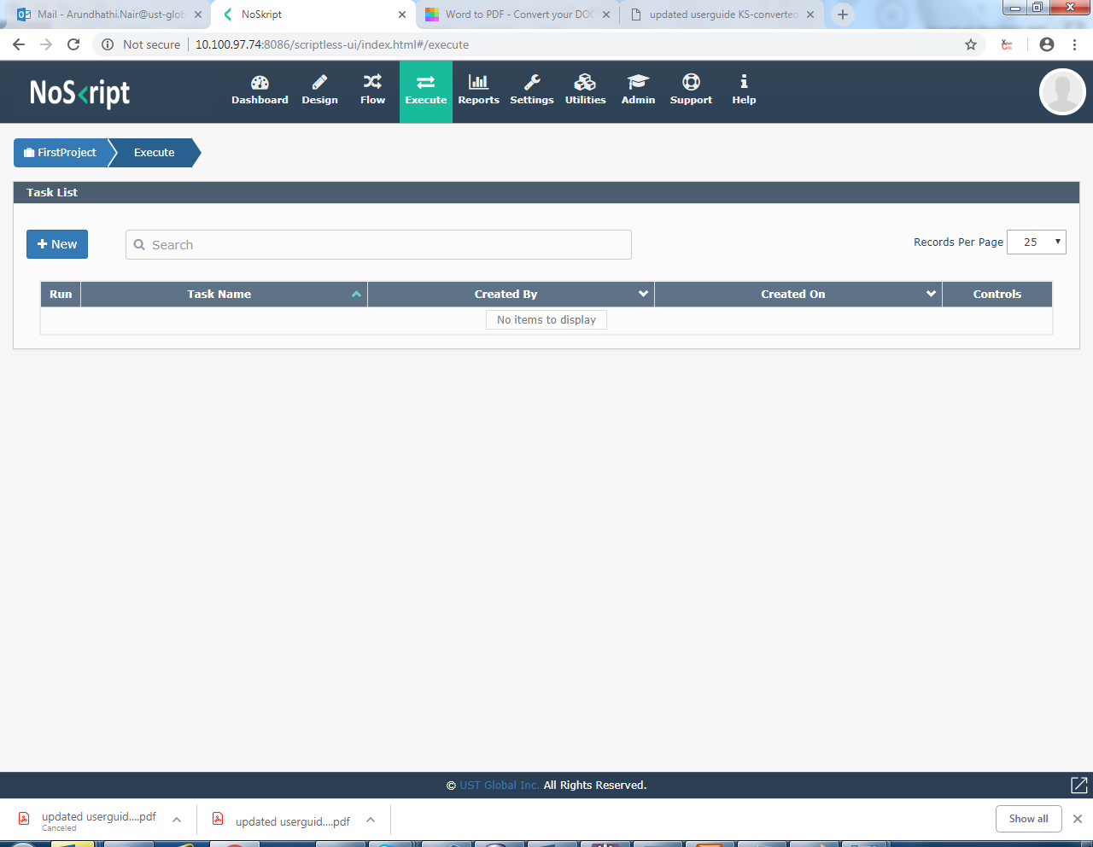

* + - * Click ‘New’ Button.
      * Select the test set.
      * Click next
      * Select the Environment and browser

Screenshot are as below

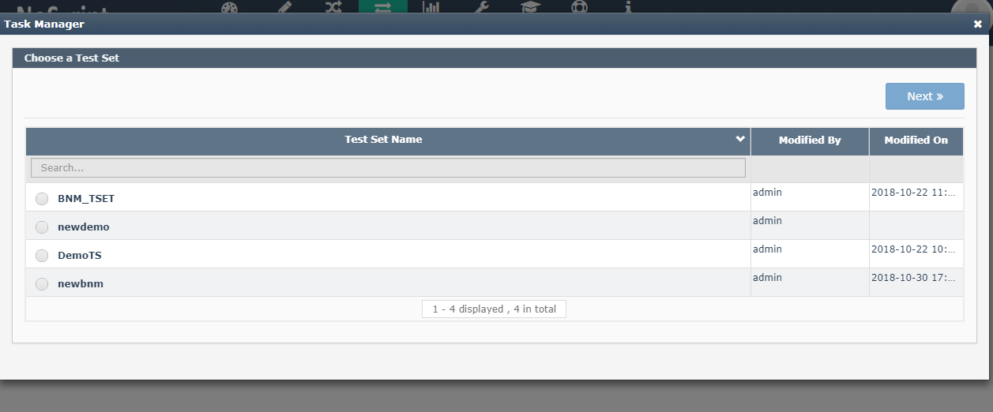

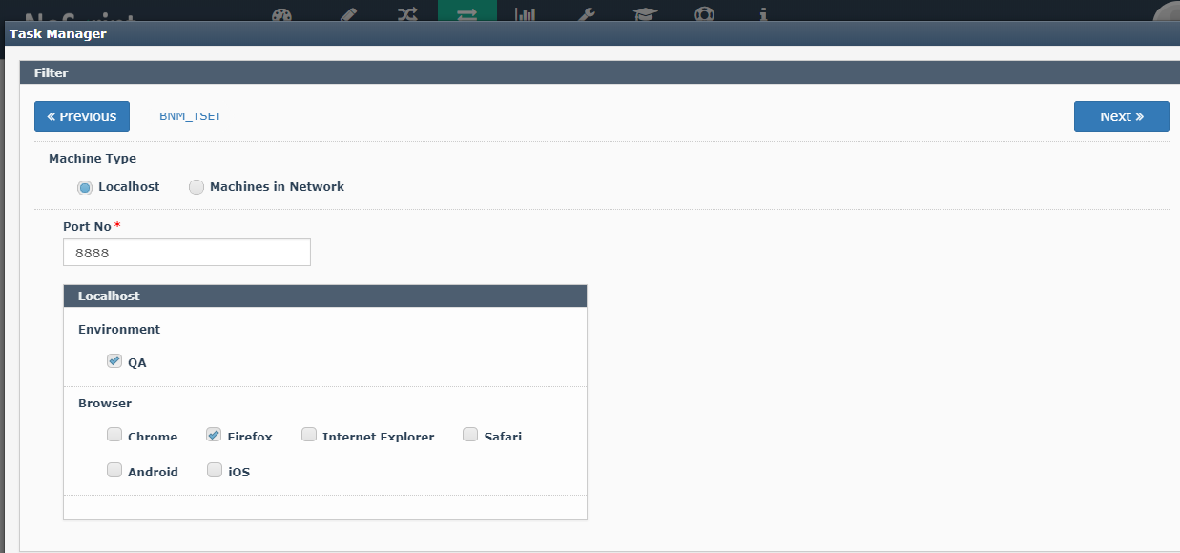

Click on Next

Enter the Task name

Enter the description

Enter the threshold value

Click save

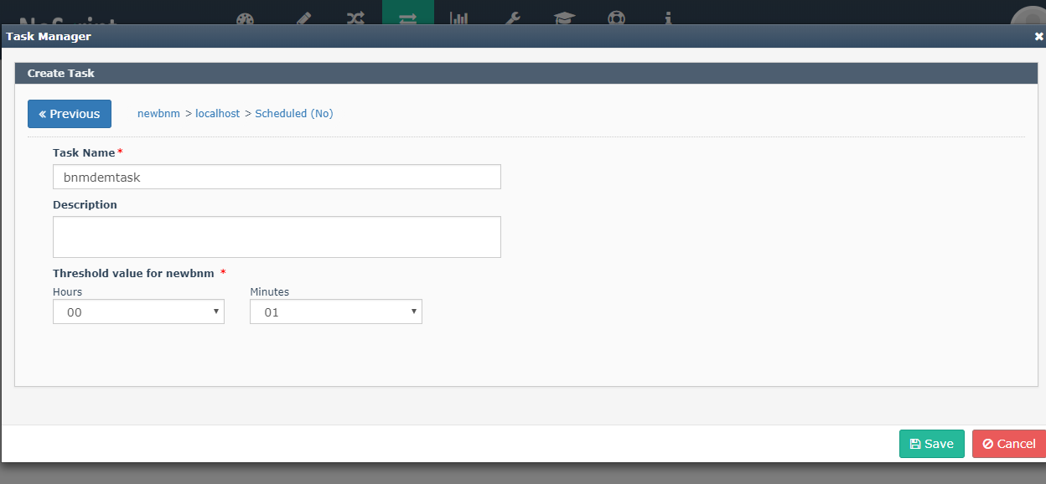

* Click on  to execute the task

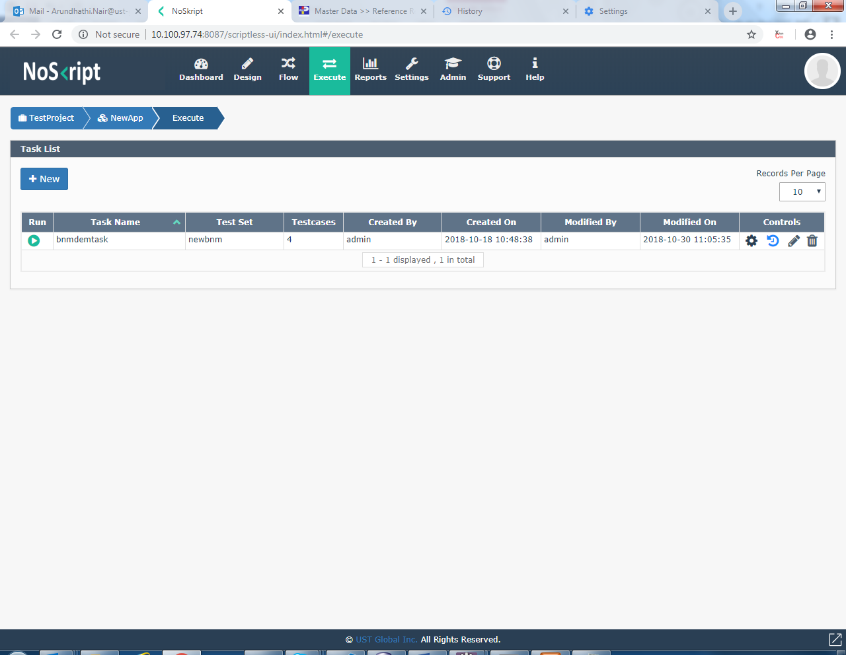

**Controls:**

: To run the task

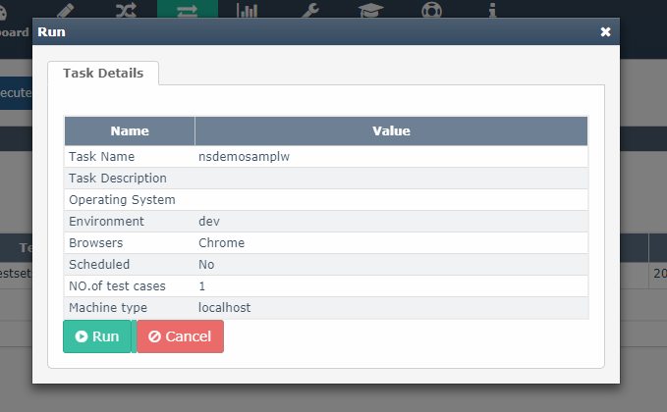

* + - Click on the run

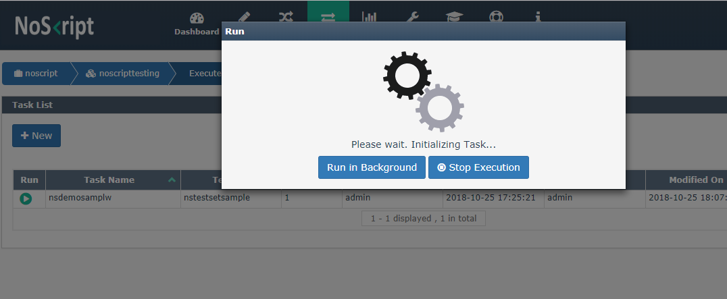

**:** To view the run history

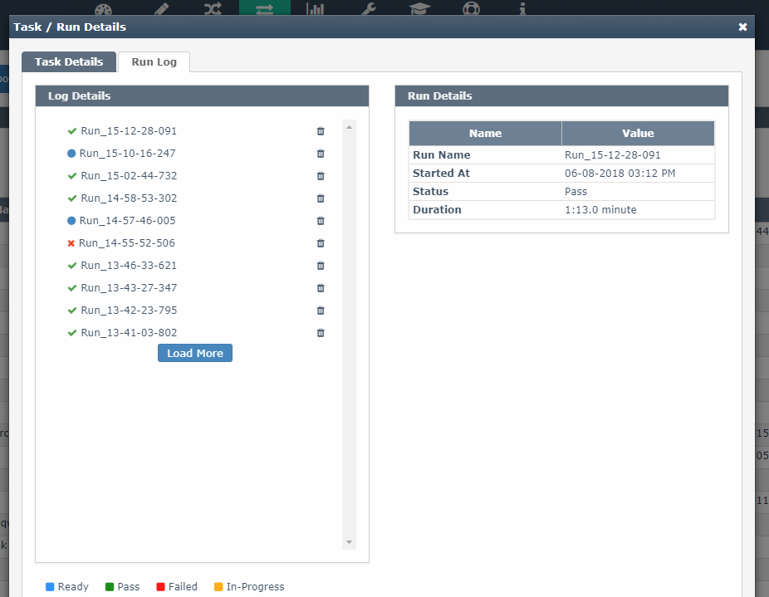

By expanding the Test execution results, user is able to view the details of the execution

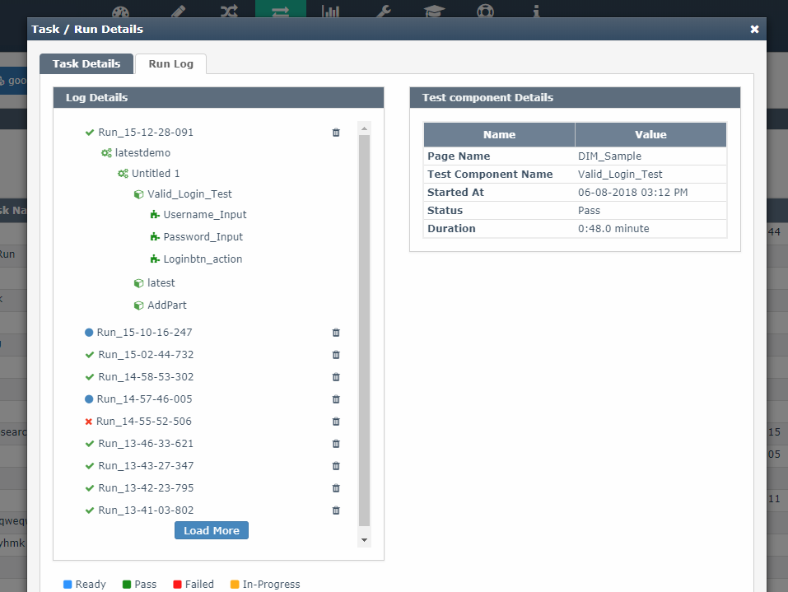

If one Test Step is failed then it will pause the test execution and will not continue with other steps.

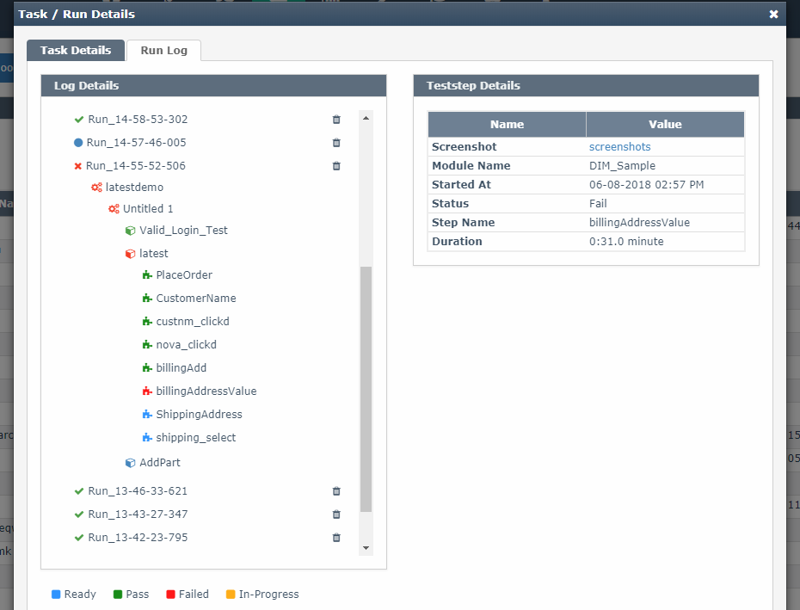

.

## Charts and Graphs

The charts and graphs tab is used to view the Report of the test execution. Click on the bar gives the details of the test report as shown below.

The report tab is used to view the charts and graph of the test execution.

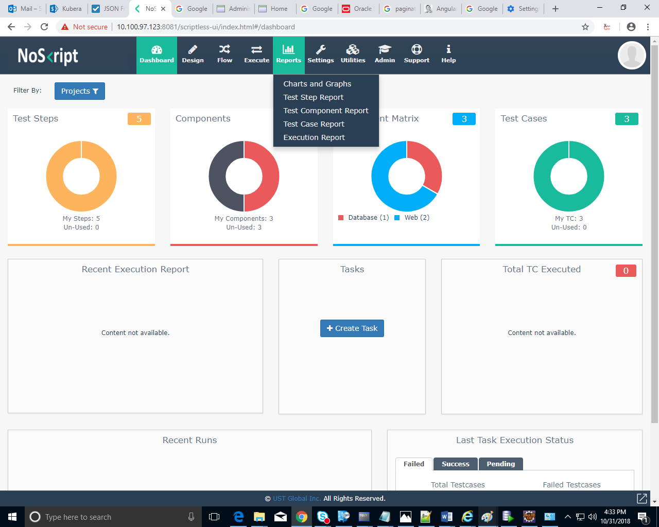

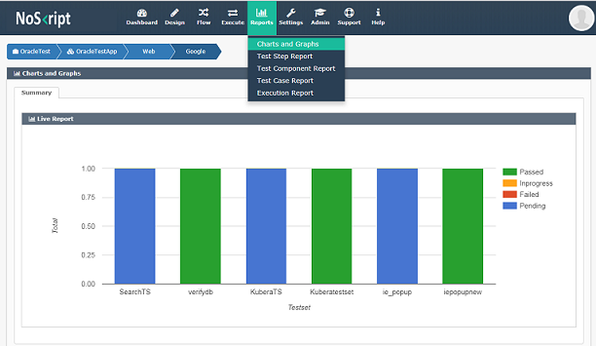

**Test Set Report**

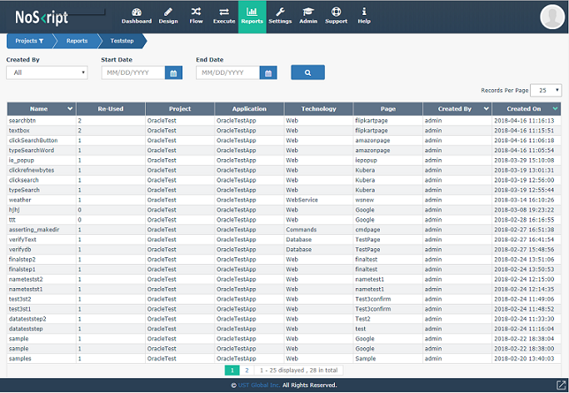

**Test Component Report**

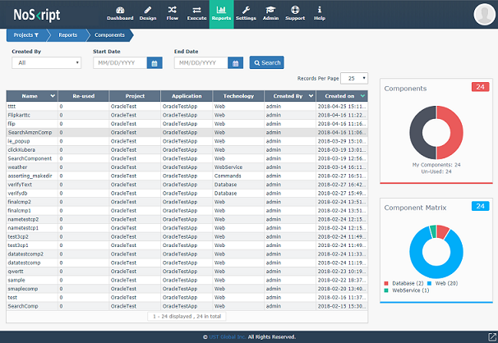

**Test Case Report**

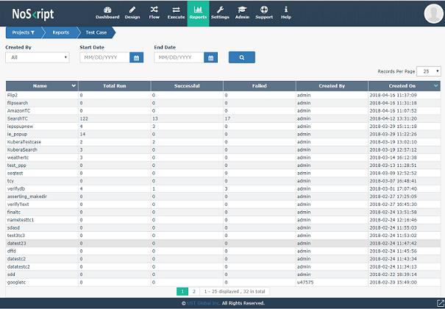

**Execution Report**

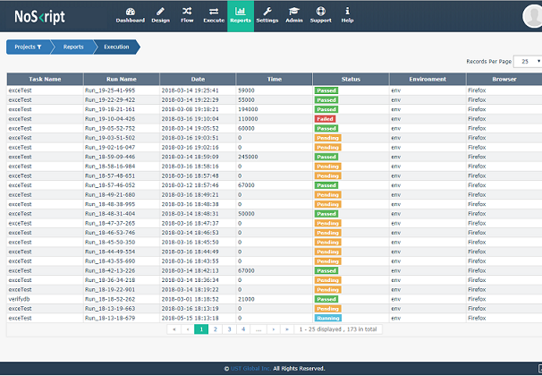

**Error Log**

.

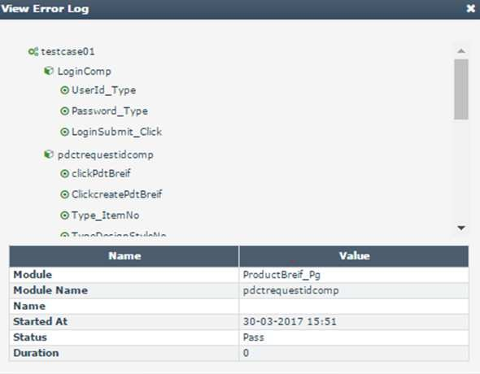

## Web service Automation

Webservice automation is used to automate ‘REST’ web services.

Like web it has test object, test step and test component in design part.

Select Webservice from the technology list. The user will taken to the page as shown below.

Create a new page using the ‘+’ button.

Screen shots are given below

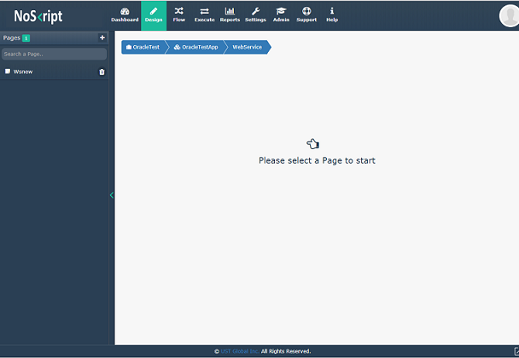

User can create new page also by giving the name of the page

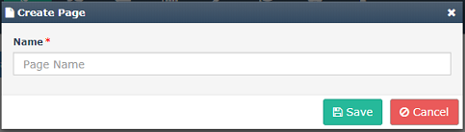

**TEST OBJECT**

* Click on the New button to create the test object.
* Here we have to select the request type and rest request url.

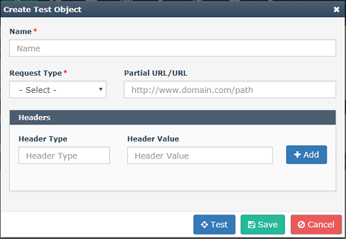

* Click on the request type dropdown and select type of request.

There are 4 request type as shown below.

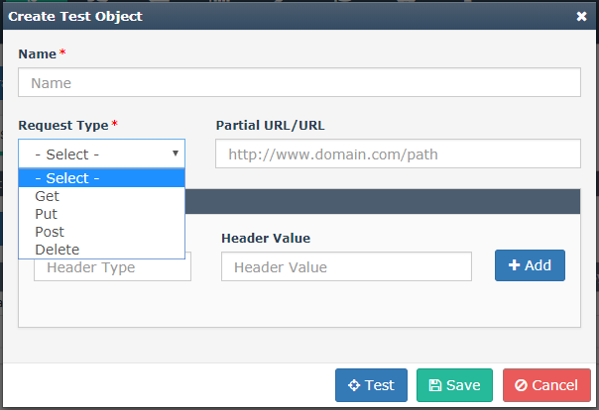

* For request type other than ‘GET’ give the request data.

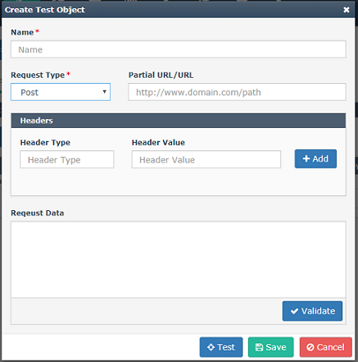

* Enter Headers with Header type and Header value. Click on the add button to save the data.
* Click on the save button to save the test object.

**TEST STEP**

Click on the New button to create test step.

* Enter the name.
* Enter the description if needed.
* Enter the Activity type either Assertion/Store.
* Click on the dropdown to select the Assertion.
* Select the object.
* Click on the Save button to save the test step.

Screenshot given below

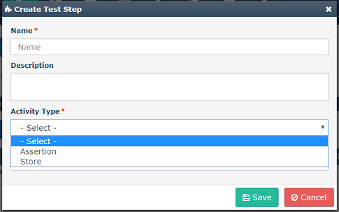

**Store** activity is used to store the value during execution and use the value further

in same execution.

Type of Assertions are shown below in the screenshot.

String manipulation is also possible by clicking the ‘String Manipulation’ tab.

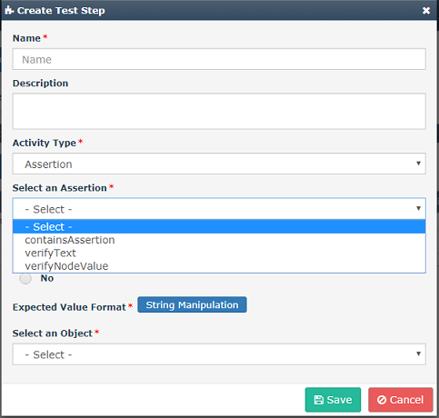

**TEST COMPONENT**

Drag and drop the Available test step to create the test component.

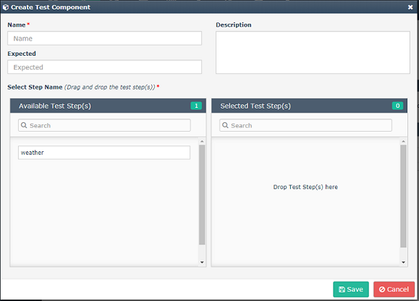

Similar to all other technologies create test case, test set and test data.

Screenshots are given below.

## 3.7CommandLine Automation

It is basically used for commands automation .

Command Line automation also starts with “ project selection” then the user will direct to select the application then the technology.

The technology selected must be “Command”.

**TEST OBJECT**

Click on the New button to create the test object.

* To create the test object command type will be given as ’linux/windows’.
* Command will be in the form of “mk_dir %s “ for activity and ” free -m” for assertion.
* Value of ‘s’ will give in next fields.
* Click the save button to save the test object.

Screenshots given below.

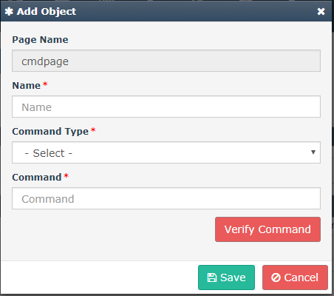

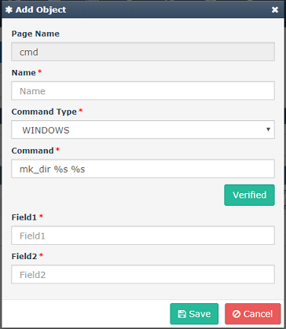

**TEST STEP**

* Click on the New button to create the test step.
* Here the activity type is ‘Action/Assertion/Store’.

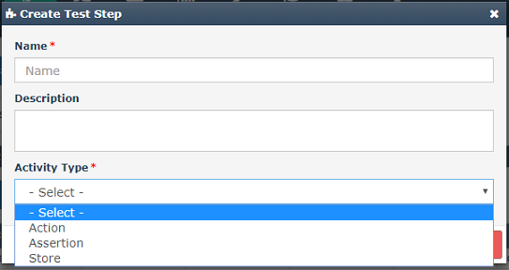

When the activity type is ’ Assertion’ select the assertion type

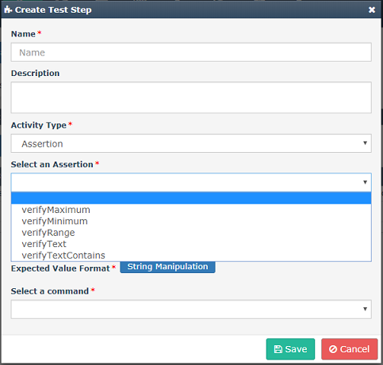

If the activity type is ’Action’ then the Action type is execute.

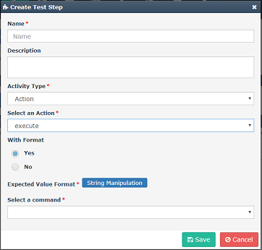

**TEST COMPONENT**

Drag and drop the test step to create the test component.

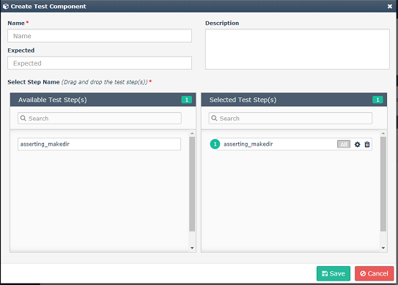

Then all the test case, test set and test data are same like earlier.

## 3.8Database Technology

In database technology we can check the database connection and the entire dB operations. During the creation of Test Object we must specify which was the Database type (MSsql,Oracle ,DB2). While Test Case creation we can verify database connection the sample data should be same as we

gave during the Technology Setting creation.

.

**TEST OBJECT**

* Click on the New button in the test object to create test object for database.
* Give the query to be verified (eg : select * from sample).
* Verify the command and save the test object.

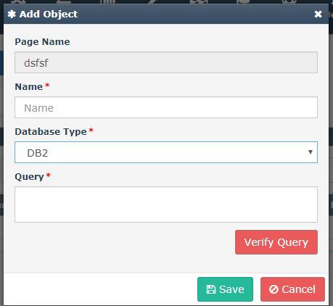

**TEST STEP**

Click on the activity type drop down to choose required type.

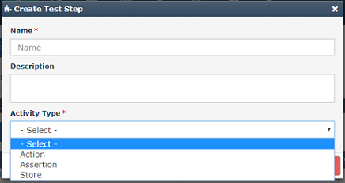

* If the activity type is ‘Assertion’ then choose assertion dropdown to select particular assertion as shown .

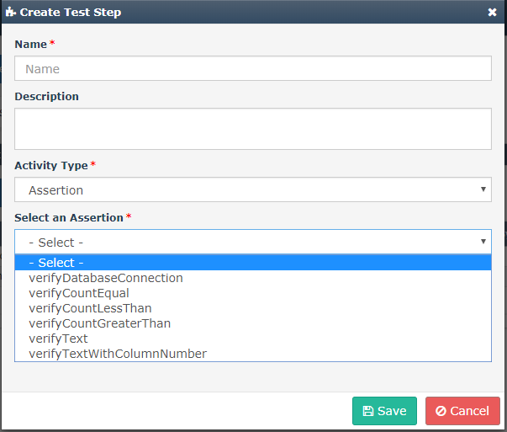

* If the activity type is ‘Action’ the action selection will be execute query as shown in the figure.

**TEST COMPONENT**

Drag and drop the test step to create the test component.

Screenshot given below.

All the step test case, test set and test data are same like earlier.

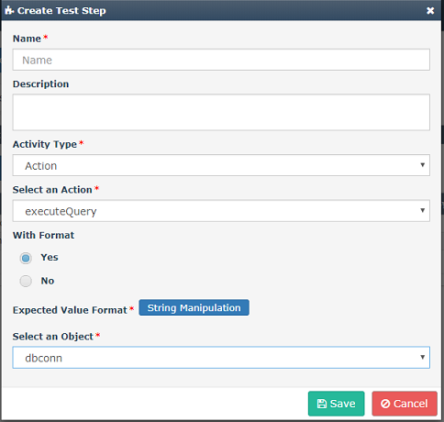

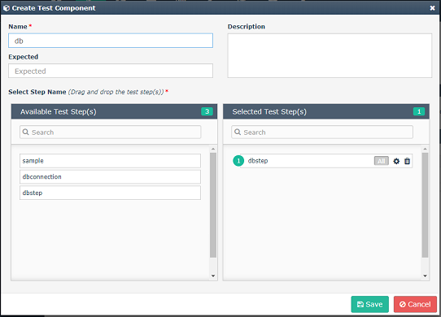

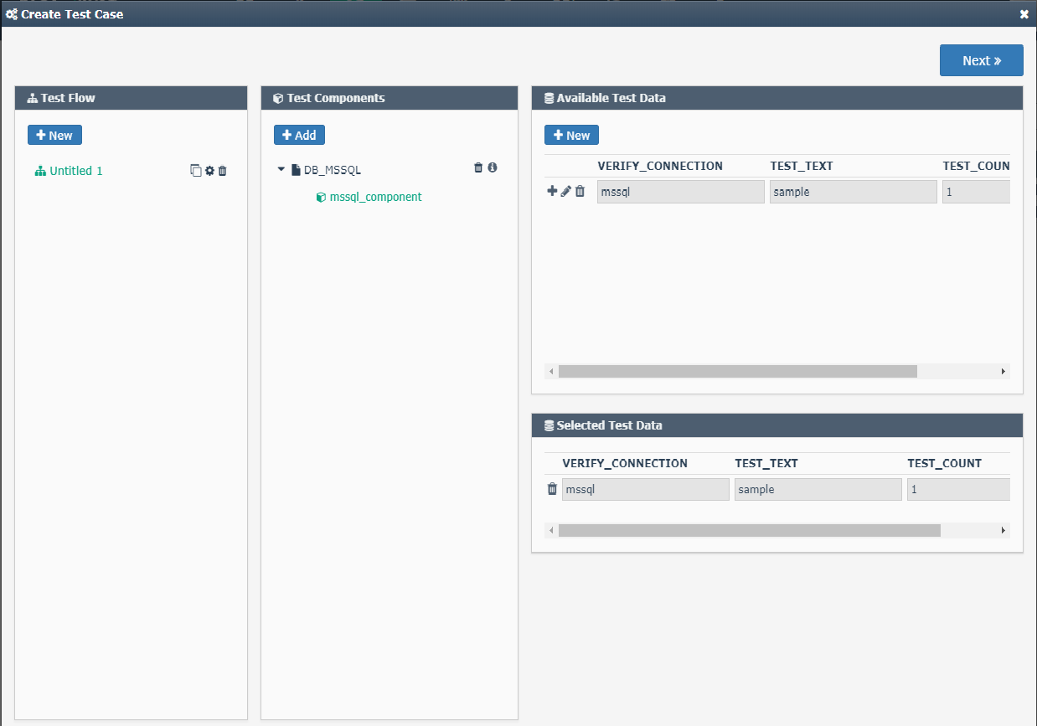

We can add the technology settings for the MSSQL/DB2 as the screenshot given below

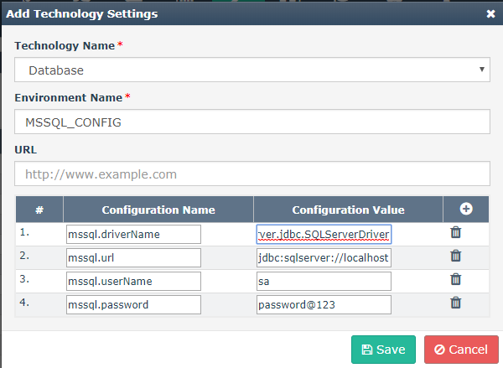

**3.9 Mobile Technology**

The technology selected must be mobile for a new project or existing project. First create the page as shown below

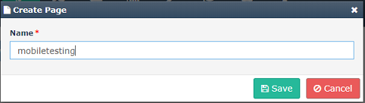

**Test object location using UI Automator**

* Connect the mobile Device to the machine using usb cable 2
* Go to Android sdk package folder-> click on tools folder-> execute uiautomatorviewer.bat file.
* Click on the Device Screenshot(uiAutomator dump)

Screenshot given below

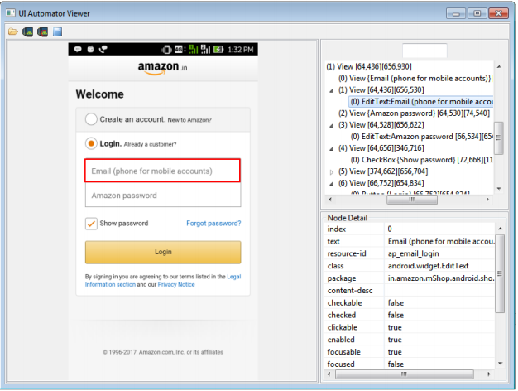

**TEST OBJECT**

* Click on the New button in the test object to create test object for Mobile.
* Give the request through test object
* Verify the command and save status into run history.

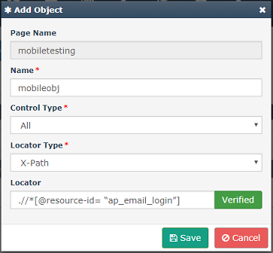

**TEST STEP**

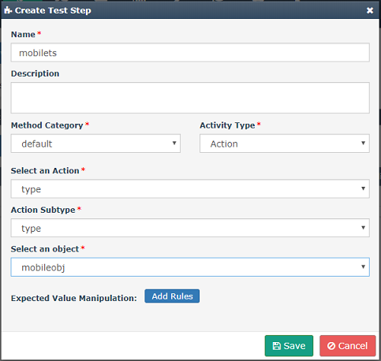

If activity type is assertion screenshot given below

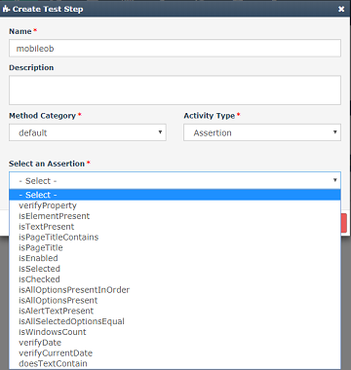

**TEST COMPONENT**

Drag and drop the test step to create the test component.

Screenshot given below.

All the step testcase , test set and test data are same like earlier.

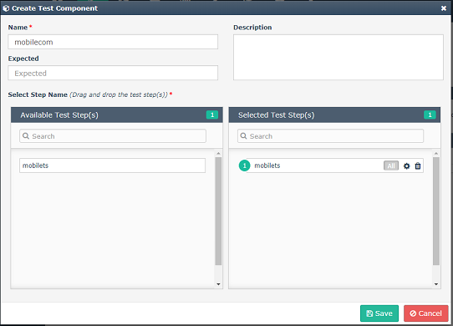

**TECHNOLOGY CONSOLIDATION**

Creating test case with all test object from different technologies.

* Select all component created for each technology and create the test case.

Screenshots given below.

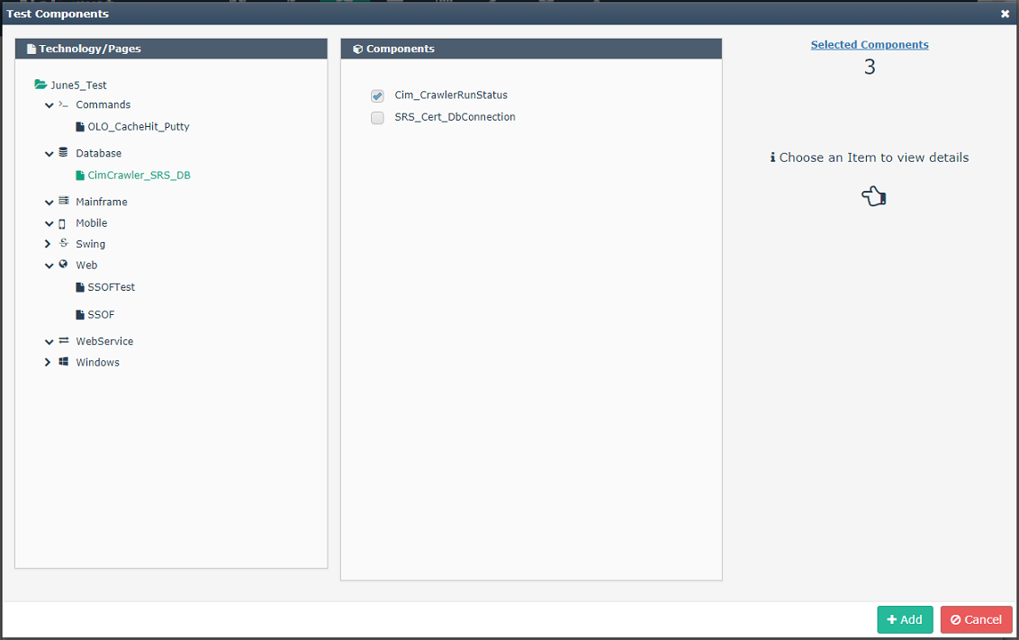

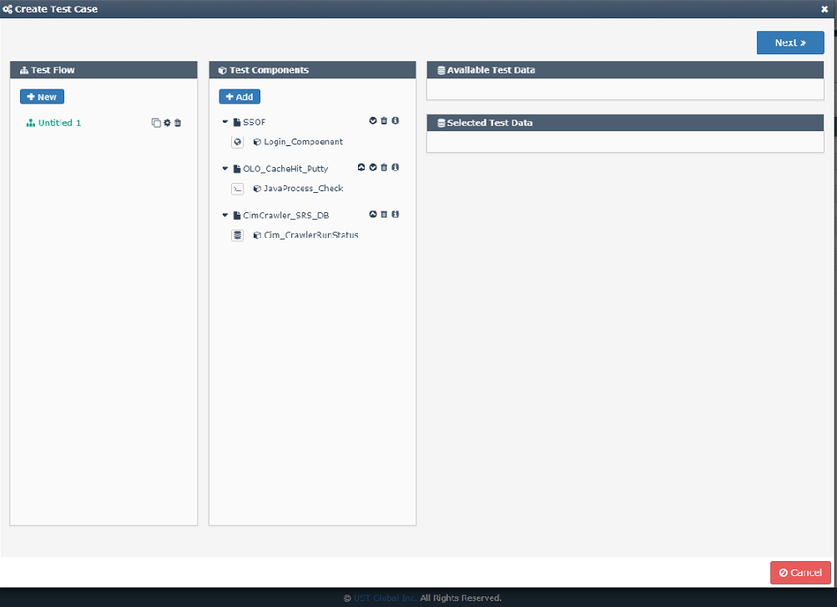

**3.10 Encryption Rules**

Encryption Rules is used for encryption purpose.

Create test object, test step and test component as mentioned earlier in ‘web Technology’.

For setting the encryption Rules.

* Click on settings and select Encryption Rules.

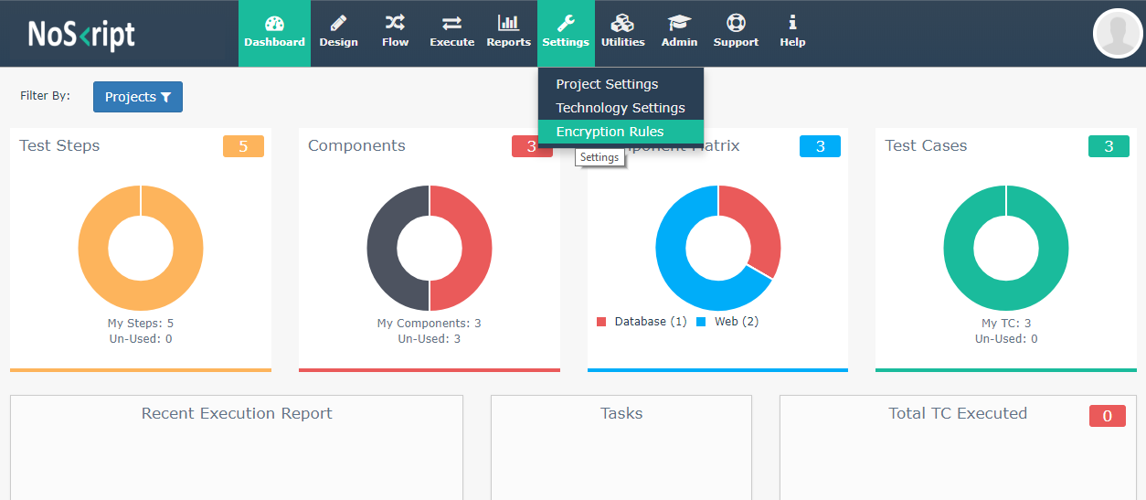

* Click on ‘New’ to create an Encryption Rule.
* Give the keyword name based on the user’s need to encrypt the data.
* Select on which all conditions the data needs to be encrypted. User can select either ’Test Object Name’ or ‘Test Object Locator’ or both.
* Fill the keyword match criteria by selecting ‘Exact’ or ‘Somewhere’ or ‘specific’.

If selected ‘Keyword Match Criteria’ is ‘Specific’ specify whether it is ‘Starts with’ or ’Ends with’

Screenshots given below

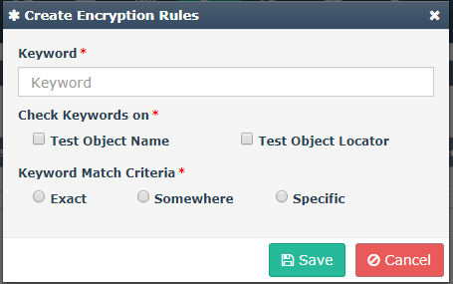

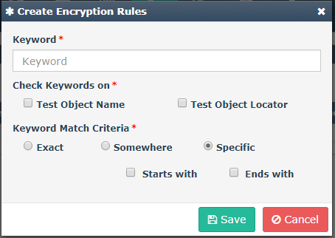

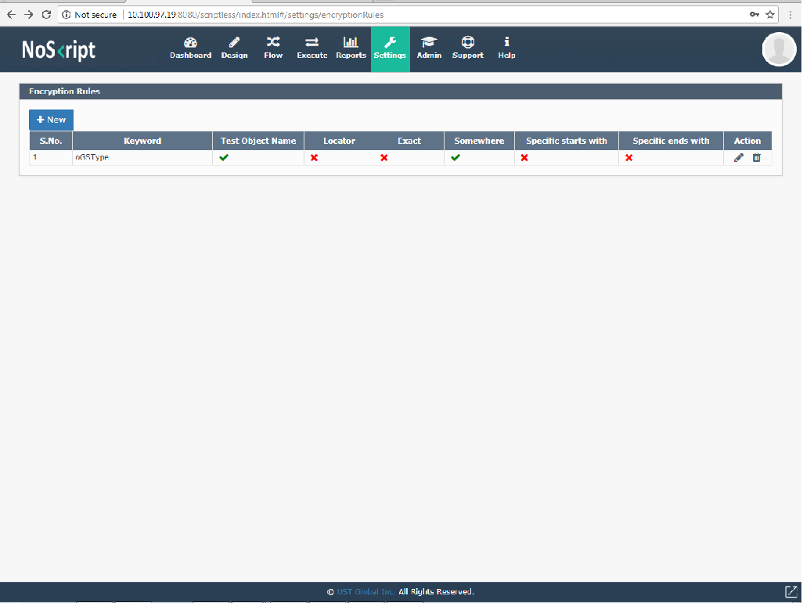

* Drag and Drop the test component to create test case.
* In ‘Test Data’ type the keyword type and then click the ‘+’sign then it will get encrypted.

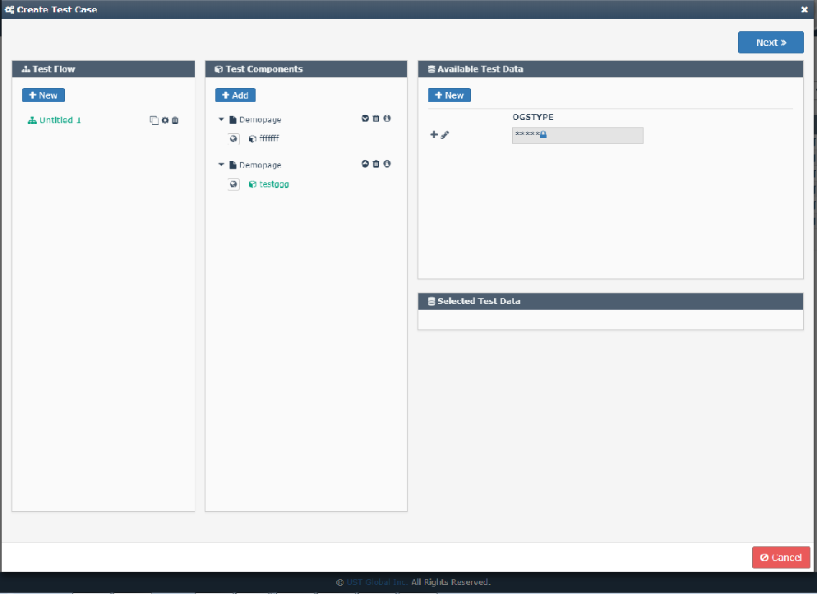

**3.11** **KILL SWITCH**

Kill switch features helps the user to terminate a task execution based on a threshold value.

This feature comes under task functionality in noskript. During the task creation, there is dropdown named "threshold" from where user can select the time in hours and minutes.

It is a mandatory field marked by redasteriks(*).

The below fig(3.11.1) shows how to set the threshold value.



Fig:3.11.1

During the execution, once the threshold value exceeds a pop up with a message "Do you want to kill the execution " will prompt. If the user select "Yes" option, in a certain seconds delay the complete execution will terminated and for "No" option the execution will continue. The screenshot is given below

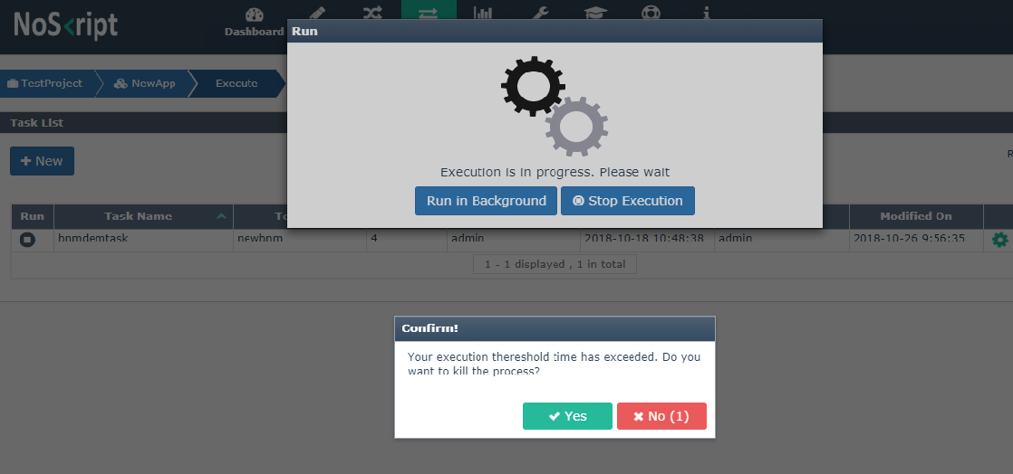

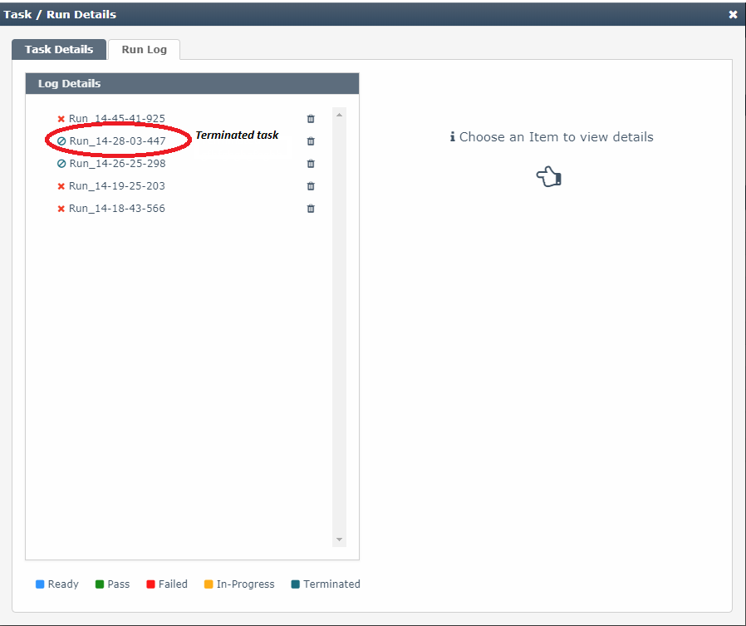

Fig:3.11.2 The Run log of the terminated task

**3.12** **DB Putty**

DB putty is a feature that is available on the **Technology settings** under settings tab,

An user can select the technology name and the environment for a task. and also it allows a user to

provide configuration details in this page .the screenshots are given below

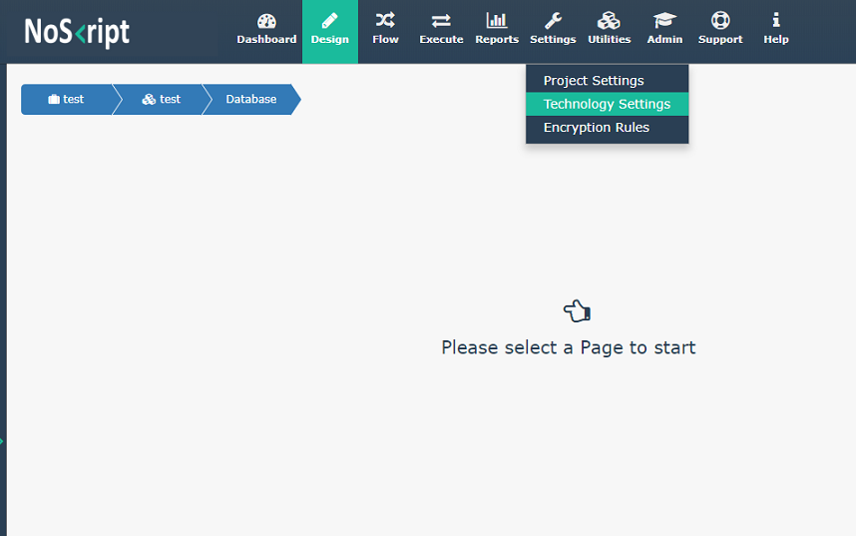

* Add technology name
* Add Environment name
* Add Configuration Details
* Click Save

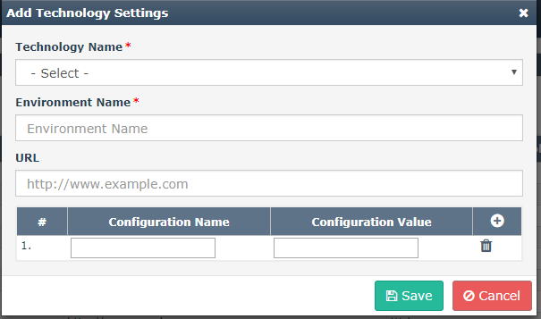

* User can add configurations for DB Putty details as shown below.

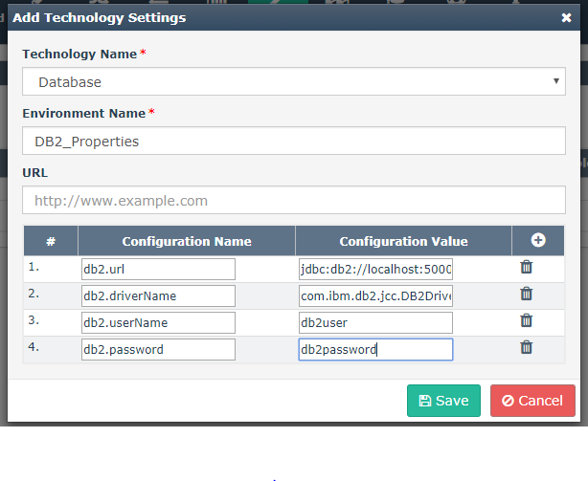

3.13 **MultiTestSet**

Earlier NoSkript Tasks were created under application level supporting only one TestSet in

a Task. Currently Task is created under Project Level. Now we have provision to create multiple TestSet under

an single Task. Initially user selects a project and can add different TestSets from Applications.

Screenshots for multiple TestSet and Task creation are as given below:-

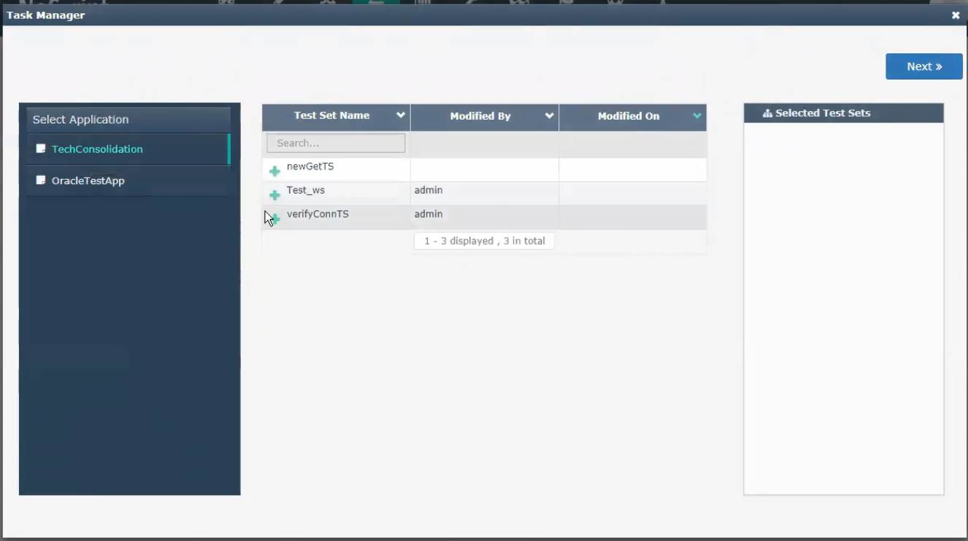

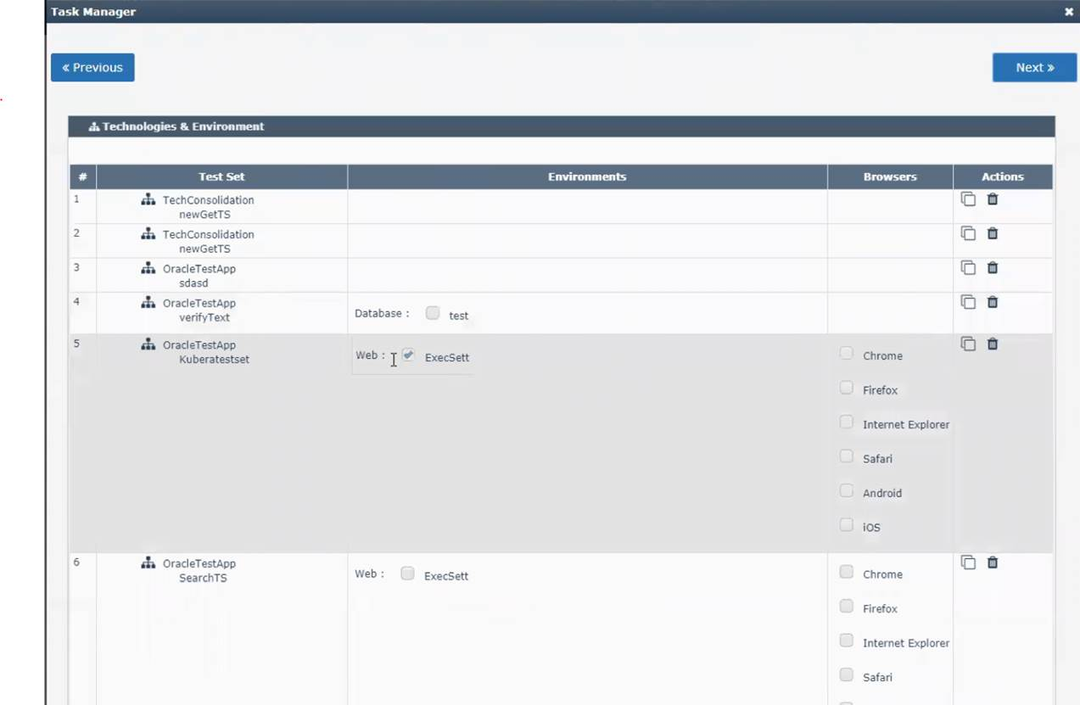

3.15 Multitestset